**Sustainable Outreach And Universal**

**Leadership (SOUL) Limited**

Software Requirement Document

**The Software Requirements Specification(SRS) is one of the first phases of system development. This phase results in the Software Requirements Specification(SRS) document, which must contain a complete, concise, high-quality description of the system being considered.**

Table of Content

## **Abstract**

Software Requirements Specification (SRS) is one of the first phases of system development. This phase results in the Software Requirements Specification (SRS) document, which must contain a complete, concise, high-quality description of the system being considered.

## **Introduction**

## Purpose

This document covers all the functional requirements of the Education module of ERP Product. The ERP Education module helps in organizing the entire education set-up, such as Student Database, Fee Structure, Staffing Information, Courses, Curriculum, Assessment and Result Declaration.

## Scope

In this module, assessment procedure is defined to evaluate the student’s curricular performance in a period. Based on the performance of the student in the assessment, Assessment results can be created for a student.

## **Definition, Acronyms and Abbreviations**

The following table explains the terms and abbreviations used in the document

|  |  |
| --- | --- |
| **Abbreviation** | **Description** |
| SRS | Software Requirements Specification |
| SLCM | Student Life Cycle Management |
| R | Rename - When a field is Renamed |
| N | New - When a New field is Added |
| D | Delete - When an Existing field is Deleted |

# Overview of the Document :

Student success is always considered as the top priority for any institution, students always are considered as the base of any educational institution. So various works are associated with students right from their admission process to the completion of their education.

Previously, all the tasks related to student success were dependent on a lot of manual work that included organizing marketing activities for universities to attract fresh prospects, track their interests, nurture them through continuous engagement, these are just some of the things that come under student life cycle management.

It enable you to manage and create quick & easy-to-use student profile information, the inquiry process, enrollment for admission, link to enroll, schedule, transcript, and degree evaluation, and share records with faculties, and administrators.

It also can track student performance from his first-class to his last class in the university that is course completion, managing information across the entire student life cycle to advance students.

# Detailed requirement

Students Management Modules ▪ Students Profile.  :Personal Information, Contact Details, Academic Details ▪ Issue of Identity Card.  ▪ Biometric Attendance (Face recognition) ▪ Hostel Management (Hostel seat allotment, attendance, fees etc) ▪ Scholarships.  ▪ Rewards and achievements.  ▪ Students’ Evaluation/remarks of Faculty.  ▪ Students Exams records of all 6 semesters ▪ Parent Enquiry/Alert/Messaging Messaging System  ▪ Students Grievance System etc

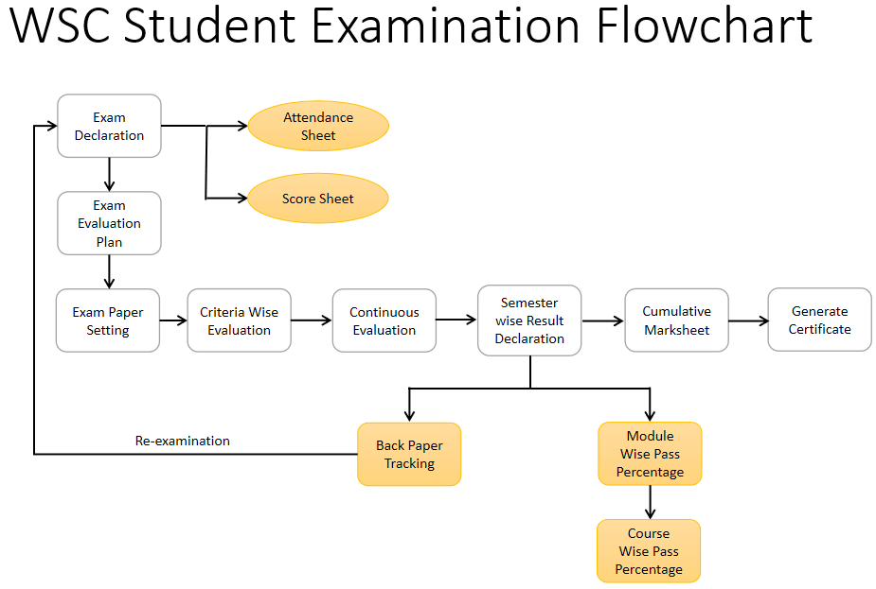

# Flowchart Description :

## Exam Declaration

The Exam Declaration will allow user to declare an exam for various programs in accordance with the ‘Academic Calendar’ template which was used during the start of each session.

## Attendance Sheet

## Score Sheet

## Exam Evaluation Plan

An Exam Evaluation Plan is a schedule to conduct the examination/assessment of a particular course for a group of students studying that course in an on-going academic term.

## Exam Paper Setting

The Exam Paper Setting is used to prepare paper setting schedules and plan for paper setters and moderators for a particular exam declaration.

## Criteria Wise Evaluation

Criteria Wise Evaluation allows us to create an evaluation for a particular assessment criterion in a course for a student enrolled in that course.

## Continuous Evaluation

Continuous Evaluation is used to assess the Assessment Criteria done for a course for an individual student.

## Semester Wise Result Declaration

Semester Wise Result Declaration is used to evaluate the final assessment of a student for a particular semester.

## Back Paper Tracking

## Module Wise Pass Percentage

## Course Wise Pass Percentage

## Cumulative Marksheet

Cumulative Marksheet is a compilation of all the semesters with their grades in a single certificate. The Cumulative marksheet will have a list of subjects, grades obtained and CGPA (Cumulative Grade Point Average). And also details of students, such as roll number, name, age and date of birth, program enrollment.

## Generate Certificate

# Overall Screen and Its Description :

|  |  |  |
| --- | --- | --- |
| Sl no | Screen Name | Description |
|  |  |  |
|  |  |  |
|  |  |  |
|  |  |  |
|  |  |  |
|  |  |  |
|  |  |  |
|  |  |  |
|  |  |  |
|  |  |  |
|  |  |  |

# Examination

# Masters Screen

The Examination Masters consists of transactions which would allow user to determine and set the values for the Examination Module to process easily. The transactions in Examination Master consists of:

a. Exam Type

b. Assessment Criteria

c. Grading Scale

d. Student Exam Block Criteria

Below is the complete workspace for Examination:

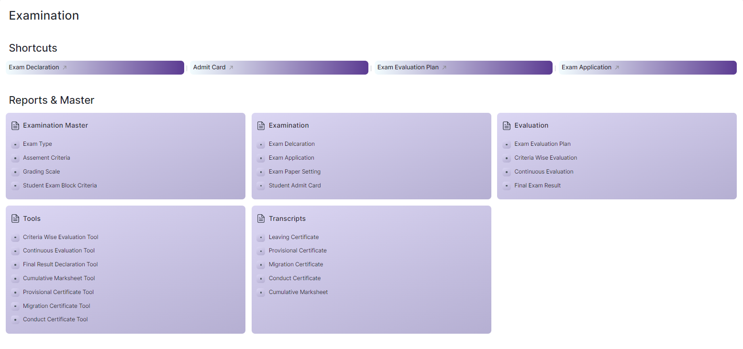

Figure 1 : Examination Home Screen

## Exam Type

|  |  |
| --- | --- |
| **Description :** | The Exam Type allows user to create and set values for a particular Exam Declaration which shall be beneficial to determine the type of examinations that are being conducted and can be evaluated on the basis of it. For example, an Exam Declaration can be classified as Mid Term Examination or End Term Examination. |
| **Navigation :** | Home > Examination > Examination Master > Exam Type |
| **Pre-requisites :** |  |
| **Existing Screen Name :** |  |
| **New Screen Name :** |  |

### **Exam Type Screenshot:**

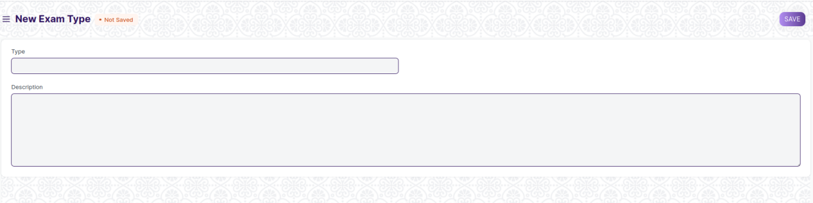

Figure 2 : Exam Type Screen

### **Exam Type Field Type:**

The “Exam Type” screen shall consist of the following fields:

|  |  |  |  |  |  |
| --- | --- | --- | --- | --- | --- |
| **Field Label** | **Field Type** | **Validation/Action** | **Mandatory** | **Remarks** | **R/N/D** |
| Type | Text Field | User Input |  |  |  |
| Description | Long Text Field | User Input |  |  |  |

### **User: Roles & Permission**

The following table describes the users and their roles and permissions for the screens :

|  |  |  |  |  |  |  |  |  |
| --- | --- | --- | --- | --- | --- | --- | --- | --- |
| **Role** | **Select** | **Read** | **Write** | **Create** | **Delete** | **Submit** | **Cancel** | **Amend** |
| Admin | Yes | Yes | Yes | Yes | Yes | NA | NA | NA |
| Instructor | No | Yes | No | No | No | NA | NA | NA |
| Student | No | Yes | No | No | No | NA | NA | NA |

## **Assessment Criteria**

|  |  |
| --- | --- |
| **Description :** | The Assessment Criteria various components of Continuous Evaluation on the basis of which evaluation shall be conducted. Also, multiple Assessment Criteria can be grouped together under Assessment Criteria Group as well as Maximum Credit can be allotted to them. It can also be linked with Exam Declaration if required. For example, Assessment Criteria can be specified as Mid Term, Practical, End Term, Quiz, Viva, etc. |
| **Navigation :** | Home > Examination > Examination Master > Assessment Criteria |
| **Pre-requisites :** |  |
| **Existing Screen Name :** |  |
| **New Screen Name :** |  |

### **Assessment Criteria Screenshot:**

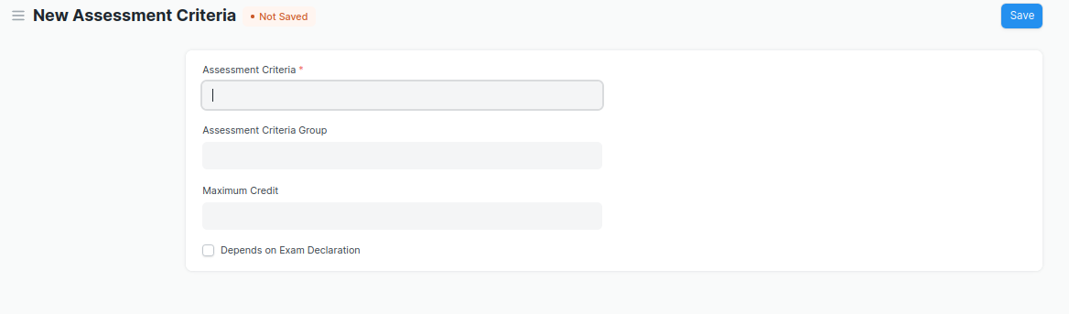

Figure 3 : Assessment Criteria Screen

### **Assessment Criteria Field Type:**

The “Assessment Criteria” screen shall consist of the following fields:

|  |  |  |  |  |  |
| --- | --- | --- | --- | --- | --- |
| **Field Label** | **Field Type** | **Validation/Action** | **Mandatory** | **Remarks** | **R/N/D** |
| Assessment Criteria | Text Field | User Input | Y |  |  |
| Assessment Criteria Group | Link Field | Fetched from Assessment Criteria Group master screen |  |  |  |
| Maximum Credit | Float | User Input |  |  |  |
| Depends on Exam Declaration | Check Box | User Input |  |  |  |

### **User: Roles & Permission**

The following table describes the users and their roles and permissions for the screens :

|  |  |  |  |  |  |  |  |  |  |
| --- | --- | --- | --- | --- | --- | --- | --- | --- | --- |
| **ID** | **Role** | **Select** | **Read** | **Write** | **Create** | **Delete** | **Submit** | **Cancel** | **Amend** |
| 1 | Admin | Yes | Yes | Yes | Yes | Yes | NA | NA | NA |
| 2 | Instructor | No | Yes | No | No | No | NA | NA | NA |
| 3 | Student | No | Yes | No | No | No | NA | NA | NA |

## Grading Scale

|  |  |
| --- | --- |
| **Description :** | Under Grading Scale, user can define the threshold for the different grades obtained by the students, based on their scores in the assessment. For example, students obtaining a score of 90% and above would be graded as A+, students obtaining a score of 80% and above would be graded A- and so on. |
| **Navigation :** | Home > Examination > Examination Master > Grading Scale |
| **Pre-requisites :** |  |
| **Existing Screen Name :** |  |
| **New Screen Name :** |  |

### **Grading Scale Screenshot:**

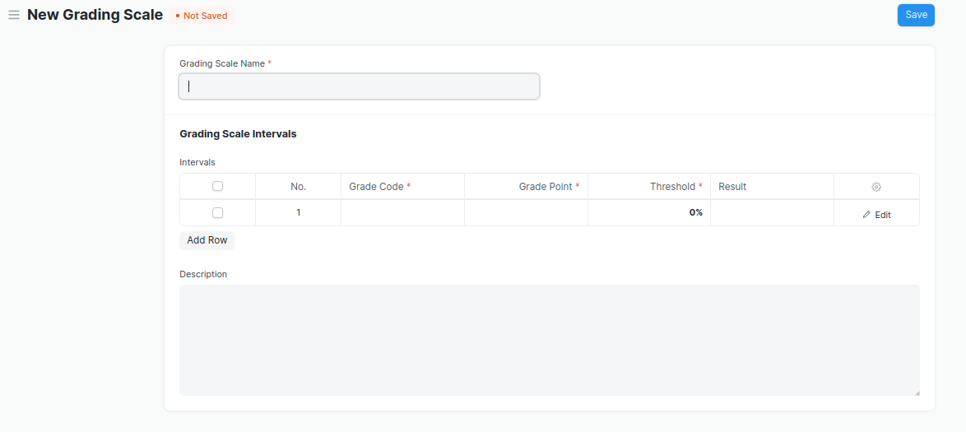

Figure 4 : Grading Scale Screen

### **Grading Scale Field Type:**

The “Grading Scale” screen shall consist of the following fields:

|  |  |  |  |  |  |
| --- | --- | --- | --- | --- | --- |
| **Field Label** | **Field Type** | **Validation/Action** | **Mandatory** | **Remarks** | **R/N/D** |
| Grading Scale Name | Text Field | User Input | Y |  |  |
| Grading Scale Interval | Table | User Input |  |  |  |
| Description | Long Text Field | User Input |  |  |  |

|  |  |  |  |  |  |
| --- | --- | --- | --- | --- | --- |
| **Grading Scale Interval** | | | | | |
| **Field Label** | **Field Type** | **Validation/Action** | **Mandatory** | **Remarks** | **R/N/D** |
| Grade Code | Text Field | User Input | Y |  |  |
| Grade Point | Text Field | User Input | Y |  |  |
| Threshold | Float | User Input | Y |  |  |
| Result | Drop Down | PASS  FAIL |  |  |  |
| Grade Description | Long Text Field | User Input |  |  |  |

### **User: Roles & Permission**

The following table describes the users and their roles and permissions for the screens :

|  |  |  |  |  |  |  |  |  |  |
| --- | --- | --- | --- | --- | --- | --- | --- | --- | --- |
| **ID** | **Role** | **Select** | **Read** | **Write** | **Create** | **Delete** | **Submit** | **Cancel** | **Amend** |
| 1 | Admin | Yes | Yes | Yes | Yes | Yes | Yes | Yes | Yes |
| 2 | Instructor | No | Yes | No | No | No | No | No | No |
| 3 | Student | No | Yes | No | No | No | No | No | No |

## Student Exam Block Criteria

|  |  |
| --- | --- |
| **Description :** | The Student Exam Block Criteria is used to create various criteria based on which students are blocked from applying for an exam declaration. For example, Attendance and Fees can be used as Student Exam Block Criteria for an Exam Declaration. |
| **Navigation :** | Home > Examination > Examination Master > Student Exam Block Criteria |
| **Pre-requisites :** |  |
| **Existing Screen Name :** |  |
| **New Screen Name :** |  |

### **Student Exam Block Criteria Screenshot:**

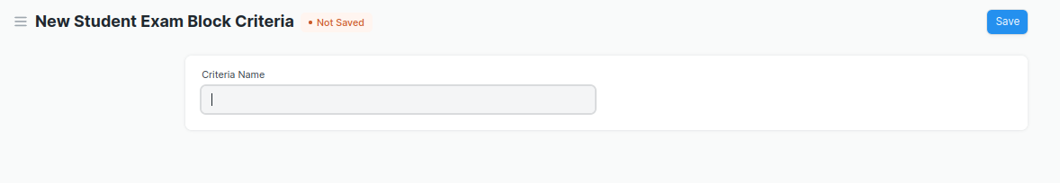

Figure 5 : Student Exam Block Criteria

### **Student Exam Block Criteria Field Type:**

The “Student Exam Block Criteria” screen shall consist of the following fields:

|  |  |  |  |  |  |
| --- | --- | --- | --- | --- | --- |
| **Field Label** | **Field Type** | **Validation/Action** | **Mandatory** | **Remarks** | **R/N/D** |
| Criteria Name | Text Field | User Input |  |  |  |

### **User: Roles & Permission**

The following table describes the users and their roles and permissions for the screens :

|  |  |  |  |  |  |  |  |  |  |
| --- | --- | --- | --- | --- | --- | --- | --- | --- | --- |
| **ID** | **Role** | **Select** | **Read** | **Write** | **Create** | **Delete** | **Submit** | **Cancel** | **Amend** |
| 1 | Admin | Yes | Yes | Yes | Yes | Yes | NA | NA | NA |
| 2 | Instructor | No | Yes | No | No | No | NA | NA | NA |
| 3 | Student | No | Yes | No | No | No | NA | NA | NA |

# Transactional Screens

## 2.1 Exam Declaration

|  |  |
| --- | --- |
| **Description :** | The Exam Declaration will allow user to declare an exam for various programs in accordance with the ‘Academic Calendar’ template which was used during the start of each session. |
| **Navigation :** | Home > Examination > Examination>Exam Declaration |
| **Pre-requisites :** | 1. Academic Calendar 2. Program 3. Academic Year |
| **Existing Screen Name :** |  |
| **New Screen Name :** |  |

### **Exam Declaration Screenshot:**

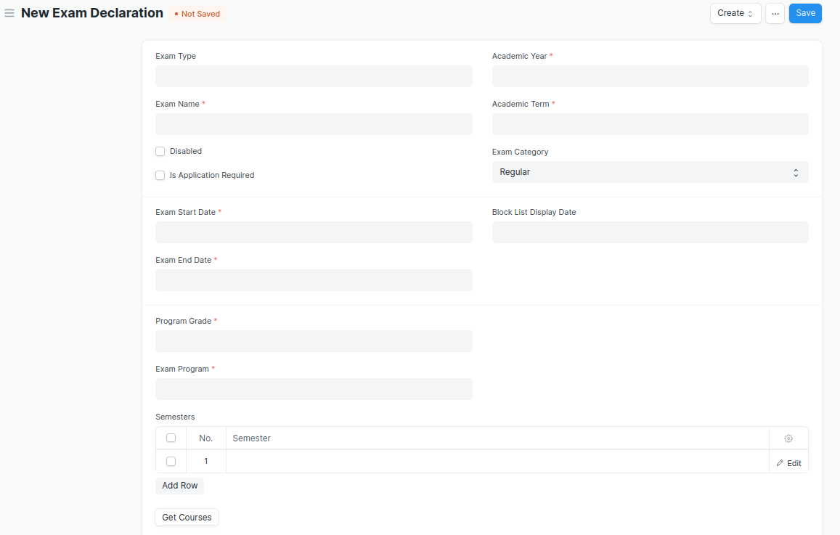

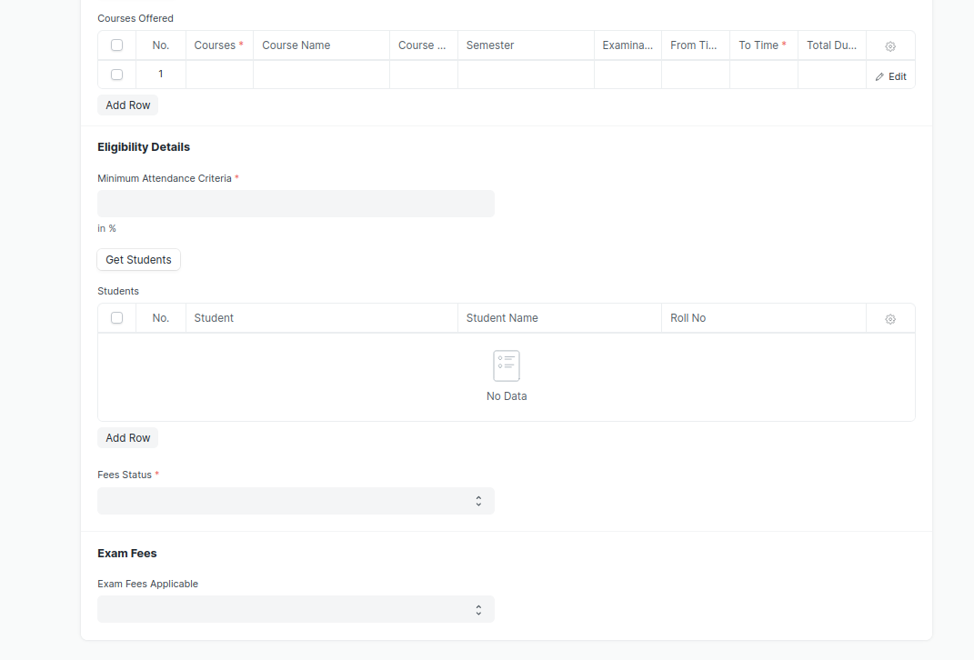

Figure 6 : Exam Declaration

### **Exam Declaration Field Type:**

The “Exam Declaration” screen shall consist of the following fields:

|  |  |  |  |  |  |
| --- | --- | --- | --- | --- | --- |
| **Field Label** | **Field Type** | **Validation/Action** | **Mandatory** | **Remarks** | **R/N/D** |
| Exam Type | Link Field | Fetched from Exam Type master screen |  |  |  |
| Exam Name | Text Field | User Input | Y |  |  |
| Disabled | Checkbox | User Input |  |  |  |
| Is Application Required | Checkbox | User Input |  |  |  |
| Academic Year | Link Field | Fetched from Academic Year master screen | Y |  |  |
| Exam Declaration Date | Date Picker | User Input |  |  |  |
| Academic Term | Link Field | Fetched from Academic Term master screen | Y |  |  |
| Exam Category | Drop down | Regular/Re-Exam |  |  |  |
| Application Form Start Date | Date Picker | User Input |  |  |  |
| Application Form End Date | Date Picker | User Input |  |  |  |
| Exam Start Date | Date Picker | User Input | Y |  |  |
| Exam End Date | Date Picker | User Input | Y |  |  |
| Admit Card Issue Date | Date Picker | User Input |  |  |  |
| Block List Display Date | Date Picker | User Input |  |  |  |
| Program Grade | Link | Fetched from Program Grades master screen | Y |  | 1. Course Grade |
| Exam Program | Link | Fetched from Programs master screen | Y |  | (R) Exam Course |
| **Semesters** | Table | Child table: Examination Semester | Y |  |  |
| Get Courses | Button |  |  |  | (R) Get Modules |
| **Courses Offered** | Table | Child table: Exam Courses | Y |  | (R) Modules Offered |
| Minimum Attendance Criteria | Float | User Input | Y |  |  |
| Certificate Creation Status | Drop down | In Process/Failed/  Successful |  |  |  |
| Get Students | Button |  |  |  |  |
| Total Enrolled Student | Int field | Calculated total number of Students fetched based on “Get Students” Button |  |  |  |
| **Students** | Table | Child table: Students |  |  |  |
| Fees Status | Drop down | Full Paid/  More than 50%/  Allow all | Y |  |  |
| Exam Fees Applicable | Drop down | YES/NO |  |  |  |
| **Fee Structure** | Table | Child table: Exam Declaration Fee Item |  |  |  |

|  |  |  |  |  |  |
| --- | --- | --- | --- | --- | --- |
| **Semesters** | | | | | |
| **Field Label** | **Field Type** | **Validation/Action** | **Mandatory** | **Remarks** | **R/N/D** |
| Semester | Link Field | Fetched from Semester master screen | Y |  |  |

|  |  |  |  |  |  |
| --- | --- | --- | --- | --- | --- |
| **Courses Offered** | | | | | |
| **Field Label** | **Field Type** | **Validation/Action** | **Mandatory** | **Remarks** | **R/N/D** |
| Courses | Link Field | Auto fetch based on “Get Courses” Button | Y |  | (R) Modules |
| Course Name | Text field | Auto fetch based on “Get Courses” Button |  |  | (R) Modules Name |
| Course Code | Text field | Auto fetch based on “Get Courses” Button |  |  | (R) Modules Code |
| Semester | Link Field | Auto fetch based on “Get Courses” Button |  |  |  |
| Examination Date | Date Picker | User Input | Y |  |  |
| From Time | Time | User Input | Y |  |  |
| To Time | Time | User Input | Y |  |  |
| Total Duration (in Hours) | Time | Calculated based on “From Time” & “To Time” |  |  |  |

|  |  |  |  |  |  |
| --- | --- | --- | --- | --- | --- |
| **Students** | | | | | |
| **Field Label** | **Field Type** | **Validation/Action** | **Mandatory** | **Remarks** | **R/N/D** |
| Student | Text Field | Auto fetch based on “Get student” Button |  |  |  |
| Student Name | Text Field | Auto fetch based on “Get student” Button |  |  |  |
| Roll No | Text Field | Auto fetch based on “Get student” Button |  |  |  |
| Registration Number | Text Field | Auto fetch based on “Get student” Button |  |  |  |

|  |  |  |  |  |  |
| --- | --- | --- | --- | --- | --- |
| **Fee Structure** | | | | | |
| **Field Label** | **Field Type** | **Validation/Action** | **Mandatory** | **Remarks** | **R/N/D** |
| Student Category | Link Field | Fetched from Student Category master screen | Y |  |  |
| Fee Structure | Link Field | Fetched from Fee Structure master screen |  |  |  |
| Amount | Currency Field | Auto fetch based on “Fee Structure” |  |  |  |
| Due Date | Date Picker |  | Y |  |  |

### **User: Roles & Permission**

The following table describes the users and their roles and permissions for the screens :

|  |  |  |  |  |  |  |  |  |  |
| --- | --- | --- | --- | --- | --- | --- | --- | --- | --- |
| **ID** | **Role** | **Select** | **Read** | **Write** | **Create** | **Delete** | **Submit** | **Cancel** | **Amend** |
| 1 | Admin | Yes | Yes | Yes | Yes | Yes | Yes | Yes | Yes |
| 2 | Instructor | No | Yes | No | No | No | No | No | No |
| 3 | Student | No | Yes | No | No | No | No | No | No |

## **2.2 Exam Evaluation Plan**

|  |  |
| --- | --- |
| **Description :** | An Exam Evaluation Plan is a schedule to conduct the examination/assessment of a particular course for a group of students studying that course in an on-going academic term. |
| **Navigation :** | Home > Examination > Evaluation > Exam Evaluation Plan |
| **Pre-requisites :** | 1. Exam Declaration 2. Instructor & Instructor Log 3. Program 4. Semester 5. Course 6. Student Group |
| **Existing Screen Name :** |  |
| **New Screen Name :** |  |

### Exam Evaluation Plan Screenshot:

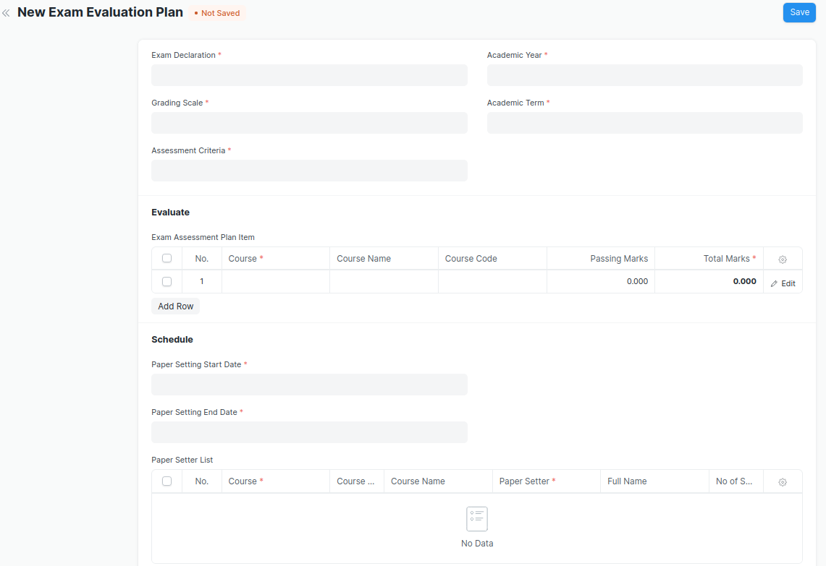

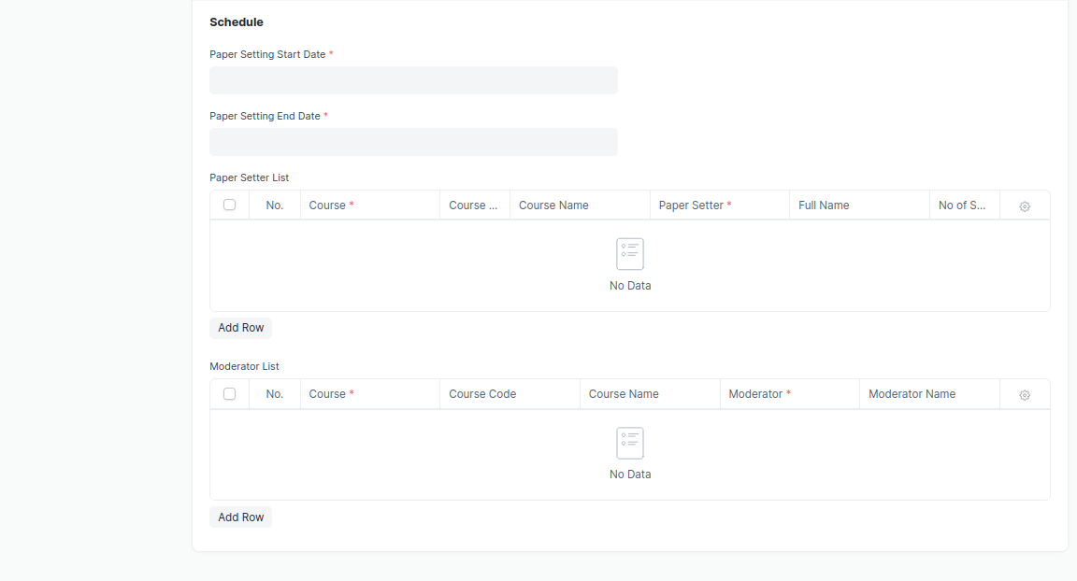

Figure 7 : Exam Evaluation Plan Screen

### Exam Evaluation Plan Field Type:

The “Exam Evaluation Plan” screen shall consist of the following fields:

|  |  |  |  |  |  |
| --- | --- | --- | --- | --- | --- |
| **Field Label** | **Field Type** | **Validation/Action** | **Mandatory** | **Remarks** | **R/N/D** |
| Exam Declaration | Link Field | Fetched from Exam Declaration master screen | Y |  |  |
| Grading Scale | Link Field | Fetched from Grading Scale master screen | Y |  |  |
| Assessment Criteria | Link Field | Fetched from Assessment Criteria master screen | Y |  |  |
| Programs | Link Field | Auto fetch based on “Exam Declaration” | Y |  | (R) Course |
| Semester | Link Field | Fetched from Semester master screen | Y |  |  |
| Academic Year | Link Field | Auto fetch based on “Exam Declaration” | Y |  |  |
| Academic Term | Link Field | Auto fetch based on “Exam Declaration” | Y |  |  |
| **Exam Assessment Plan Item** | Table | Child Table: Course Assessment Plan Item | Y |  |  |
| Paper Setting Start Date | Date Picker | User Input | Y |  |  |
| Paper Setting End Date | Date Picker | User Input | Y |  |  |
| **Paper Setter List** | Table | Child Table: Moderator List |  |  |  |
| **Moderator List** | Table | Child Table: Exam Assessment Plan |  |  |  |

|  |  |  |  |  |  |
| --- | --- | --- | --- | --- | --- |
| **Exam Assessment Plan Item** | | | | | |
| **Field Label** | **Field Type** | **Validation/Action** | **Mandatory** | **Remarks** | **R/N/D** |
| Course | Link Field | Auto fetch based on “Programs” & “Semester” | Y |  | (R) Module |
| Course Name | Text Field | Auto fetch based on Course |  |  | (R) Module Name |
| Course Code | Text Field | Auto fetch based on Course |  |  | (R) Module Code |
| Passing Marks | Numeric Field |  |  |  |  |
| Total Marks | Numeric Field |  | Y |  |  |
| Total Credit | Numeric Field |  | Y |  |  |

|  |  |  |  |  |  |
| --- | --- | --- | --- | --- | --- |
| **Paper Setter List** | | | | | |
| **Field Label** | **Field Type** | **Validation/Action** | **Mandatory** | **Remarks** | **R/N/D** |
| Course | Link Field | Only fetch those courses which belongs to the selected semester | Y |  | (R) Module |
| Course Code | Text Field | Auto fetch based on Course |  |  | (R) Module Code |
| Course Name | Text Field | Auto fetch based on Course |  |  | (R) Module Name |
| Paper Setter | Link Field | Fetched from Instructor master screen | Y |  |  |
| Full Name | Text Field | Auto fetch based on Paper Setter |  |  |  |
| No of Sets | Numeric Field |  | Y |  |  |

|  |  |  |  |  |  |  |
| --- | --- | --- | --- | --- | --- | --- |
| **Moderator List** | | | | | | |
| **Field Label** | **Field Type** | | **Validation/Action** | **Mandatory** | **Remarks** | **R/N/D** |
| Course | Link Field | Fetched those course which are present in Paper setter list | | Y |  | (R) Module |
| Course Code | Text Field | Auto fetch based on Course | |  |  | (R) Module Code |
| Course Name | Text Field | Auto fetch based on Course | |  |  | (R) Module Name |
| Moderator | Link Field | Fetched from Instructor master screen | | Y |  |  |
| Moderator Name | Text Field | Auto fetch based on Moderator | |  |  |  |

### **User: Roles & Permission**

The following table describes the users and their roles and permissions for the screens :

|  |  |  |  |  |  |  |  |  |  |
| --- | --- | --- | --- | --- | --- | --- | --- | --- | --- |
| **ID** | **Role** | **Select** | **Read** | **Write** | **Create** | **Delete** | **Submit** | **Cancel** | **Amend** |
| 1 | Admin | Yes | Yes | Yes | Yes | Yes | Yes | Yes | Yes |
| 2 | Instructor | Yes | Yes | Yes | Yes | No | Yes | No | No |
| 3 | Student | No | Yes | No | No | No | No | No | No |

## **2.3 Exam Paper Setting**

|  |  |
| --- | --- |
| **Description :** | The Exam Paper Setting is used to prepare paper setting schedules and plan for paper setters and moderators for a particular exam declaration. |
| **Navigation :** | Home > Examination > Examination> Exam Paper |
| **Pre-requisites :** | Exam Evaluation Plan |
| **Existing Screen Name :** |  |
| **New Screen Name :** |  |

### Exam Paper Setting Screenshot:

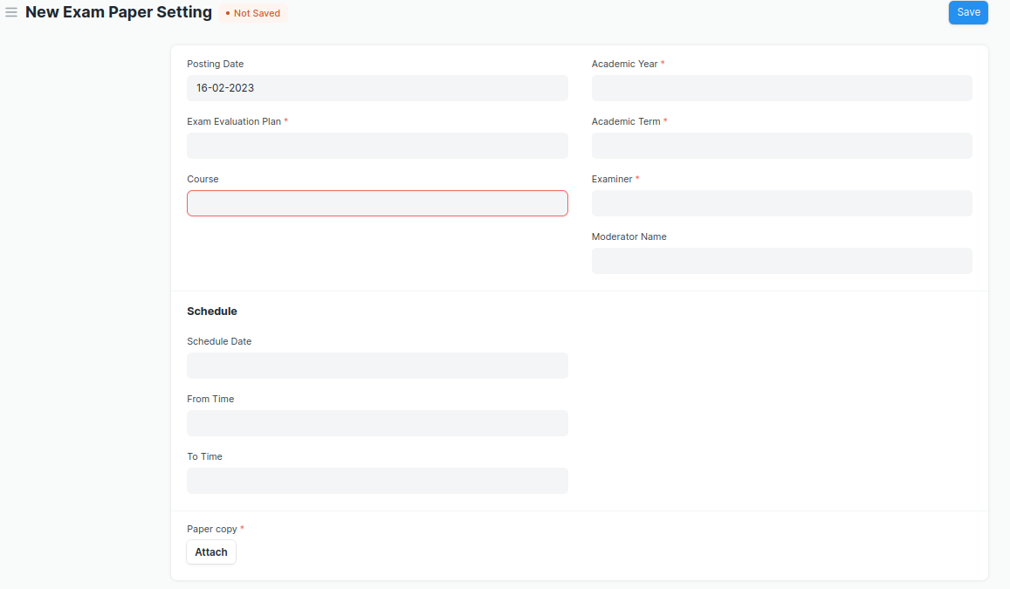

Figure 8 : Exam Paper Setting Screen

* After the paper setter moderator list is published, the paper setter will take three weeks to set the paper, and the moderator will take one week to check the paper sets.
* The paper gets reviewed by the reviewer. In case reviewer is unavailable, the paper is reviewed by Dy Director.

### Exam Paper Setting **Field Type:**

The “Exam Paper Setting” screen shall consist of the following fields:

|  |  |  |  |  |  |
| --- | --- | --- | --- | --- | --- |
| **Field Label** | **Field Type** | **Validation/Action** | **Mandatory** | **Remarks** | **R/N/D** |
| Posting Date | Date | By default Today’s date is fetched |  |  |  |
| Exam Evaluation Plan | Link Field | Fetched from Exam Assessment Plan master screen | Y |  |  |
| Programs | Link Field | Auto fetched based on “Exam Evaluation Plan” |  |  | (R) Course |
| Semester | Link Field | Auto fetched based on “Exam Evaluation Plan” |  |  |  |
| Course | Link Field | Course will be fetched based on selected “Exam Evaluation Plan” | Y |  | (R) Module |
| Course Code | Text Field | Auto fetch based on Course |  |  | (R) Module Code |
| Course Name | Text Field | Auto fetch based on Course |  |  | (R) Module Name |
| Academic Year | Link Field | Auto fetched based on “Exam Evaluation Plan” | Y |  |  |
| Academic Term | Link Field | Auto fetched based on “Exam Evaluation Plan” | Y |  |  |
| Examiner | Link Field | Examiner will be fetched based on selected “Exam Evaluation Plan” |  |  |  |
| Examiner Name | Text Field | Examiner will be fetched based on selected “Exam Evaluation Plan” |  |  |  |
| Moderator Name | Link Field | Examiner will be fetched based on selected “Exam Evaluation Plan” |  |  |  |
| Schedule Date | Date picker | User Input |  |  |  |
| From Time | Time picker | User Input |  |  |  |
| To Time | Time picker | User Input |  |  |  |
| Paper copy | Attachment Button | Attach button will only visible to that instructor whose name is provided in paper setter list | Y |  |  |
| **Assessment Plan Criteria** | Table | Child Table: Assessment Plan Criteria |  |  |  |

|  |  |  |  |  |  |
| --- | --- | --- | --- | --- | --- |
| **Assessment Plan Criteria** | | | | | |
| **Field Label** | **Field Type** | **Validation/Action** | **Mandatory** | **Remarks** | **R/N/D** |
| Assessment Criteria | Link Field | Fetched from Assessment Criteria master screen |  |  |  |
| Maximum Score | Numeric Field |  |  |  |  |

### **User: Roles & Permission**

The following table describes the users and their roles and permissions for the screens :

|  |  |  |  |  |  |  |  |  |  |
| --- | --- | --- | --- | --- | --- | --- | --- | --- | --- |
| **ID** | **Role** | **Select** | **Read** | **Write** | **Create** | **Delete** | **Submit** | **Cancel** | **Amend** |
| 1 | Admin | Yes | Yes | Yes | Yes | Yes | Yes | Yes | Yes |
| 2 | Instructor | Yes | Yes | Yes | Yes | No | Yes | No | No |
| 3 | Student | No | Yes | No | No | No | No | No | No |

## **2.4 Criteria Wise Evaluation**

|  |  |
| --- | --- |
| **Description :** | Criteria Wise Evaluation allows us to create an evaluation for a particular assessment criterion in a course for a student enrolled in that course. |
| **Navigation :** | Home > Examination > Evaluation > Criteria Wise Evaluation |
| **Pre-requisites :** | 1. Exam Declaration 2. Course 3. Assessment Criteria 4. Grading Scale |
| **Existing Screen Name :** |  |
| **New Screen Name :** |  |

### Criteria Wise Evaluation Screenshot:

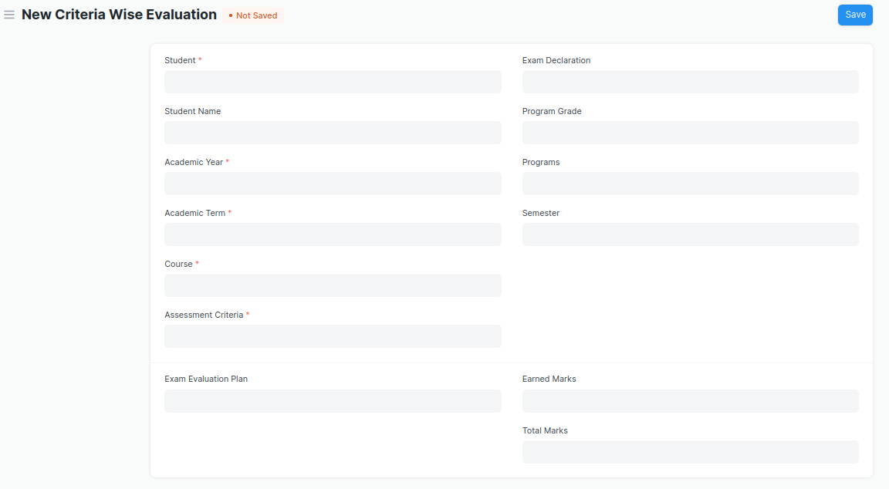

Figure 9 : Criteria Wise Evaluation Screen

* Two instructors independently evaluate a student's assessment without knowing the other's score and then come together to compare their results and determine the final grade.

### Criteria Wise Evaluation **Field Type:**

The “Criteria Wise Evaluation” screen shall consist of the following fields:

|  |  |  |  |  |  |
| --- | --- | --- | --- | --- | --- |
| **Field Label** | **Field Type** | **Validation/Action** | **Mandatory** | **Remarks** | **R/N/D** |
| Student | Link Field | Fetched from student master screen | Y |  |  |
| Student Name | Text Field | Auto fetch based on Student |  |  |  |
| Roll No | Text Field | Auto fetch based on Student |  |  |  |
| Registration Number | Text Field | Auto fetch based on Student |  |  |  |
| Academic Year | Link Field | Fetched from Academic Year master screen | Y |  |  |
| Academic Term | Link Field | Fetched from Academic Term master screen | Y |  |  |
| Course | Link Field | Fetched from Course master screen | Y |  | (R) Module |
| Course Name | Text Field | Auto fetch based on Course |  |  | (R) Module Name |
| Assessment Criteria | Link Field | Fetched from Assessment Criteria master screen | Y |  |  |
| Exam Declaration | Link Field | Fetched from Exam Declaration master screen |  |  |  |
| Program Grade | Link Field | Fetched from Program Grades master screen |  |  | (R) Course Grade |
| Programs | Link Field | Fetched from Programs master screen |  |  | (R) Course |
| Semester | Link Field | Fetched from Program master screen |  |  |  |
| Exam Assessment Plan | Link Field | Fetched from Exam Assessment Plan master screen |  |  |  |
| Earned Marks | Float |  |  |  |  |
| Total Marks | Float |  |  |  |  |

### **User: Roles & Permission**

The following table describes the users and their roles and permissions for the screens :

|  |  |  |  |  |  |  |  |  |  |
| --- | --- | --- | --- | --- | --- | --- | --- | --- | --- |
| **ID** | **Role** | **Select** | **Read** | **Write** | **Create** | **Delete** | **Submit** | **Cancel** | **Amend** |
| 1 | Admin | Yes | Yes | Yes | Yes | Yes | Yes | Yes | Yes |
| 2 | Instructor | Yes | Yes | Yes | Yes | No | Yes | No | No |
| 3 | Student | No | Yes | No | No | No | No | No | No |

## **2.5 Criteria Wise Evaluation Tool**

|  |  |
| --- | --- |
| **Description :** | Criteria Wise Evaluation Tool helps in entering marks earned by the students in a semester for  a particular course and particular assessment criteria. |
| **Navigation :** | Home > Examination > Tools > Criteria Wise Evaluation Tool |
| **Pre-requisites :** | 1. Exam Declaration 2. Course 3. Assessment Criteria 4. Grading Scale |
| **Existing Screen Name :** |  |
| **New Screen Name :** |  |

### Criteria Wise Evaluation Tool Screenshot:

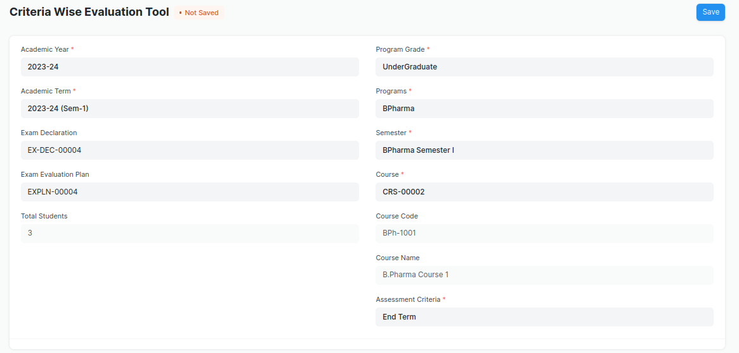

Figure 10 : Criteria Wise Evaluation Tool Screen

* Two instructors independently evaluate a student's assessment without knowing the other's score and then come together to compare their results and determine the final grade.

### Criteria Wise Evaluation **Tool Field Type:**

The “Criteria Wise Evaluation Tool” screen shall consist of the following fields:

|  |  |  |  |  |  |
| --- | --- | --- | --- | --- | --- |
| **Field Label** | **Field Type** | **Validation/Action** | **Mandatory** | **Remarks** | **R/N/D** |
| Academic Year | Link Field | Fetched from Academic Year master screen | Y |  |  |
| Academic Term | Link Field | Fetched from Academic Term master screen | Y |  |  |
| Exam Declaration | Link Field | Fetched from Exam Declaration master screen |  |  |  |
| Exam Assessment Plan | Link Field | Fetched from Exam Assessment Plan master screen |  |  |  |
| Total Students | Int Field |  |  |  |  |
| Program Grade | Link Field | Fetched from Program Grades master screen |  |  | (R)  Course Grade |
| Programs | Link Field | Fetched from Programs master screen |  |  | (R)  Courses |
| Semester | Link Field | Fetched from Program master screen |  |  |  |
| Course | Link Field | Fetched from Course master screen | Y |  | (R)  Module |
| Course Code | Text Field | Auto fetch based on Course |  |  | (R)  Module Code |
| Course Name | Text Field | Auto fetch based on Course |  |  | (R)  Module Name |
| Assessment Criteria | Link Field | Fetched from Assessment Criteria master screen | Y |  |  |
| Student Details Data | Table | HTML |  |  |  |

### **User: Roles & Permission**

The following table describes the users and their roles and permissions for the screens :

|  |  |  |  |  |  |  |  |  |  |
| --- | --- | --- | --- | --- | --- | --- | --- | --- | --- |
| **ID** | **Role** | **Select** | **Read** | **Write** | **Create** | **Delete** | **Submit** | **Cancel** | **Amend** |
| 1 | Admin | Yes | Yes | Yes | Yes | Yes | Yes | Yes | Yes |
| 2 | Instructor | Yes | Yes | Yes | Yes | No | Yes | No | No |
| 3 | Student | No | Yes | No | No | No | No | No | No |

## **2.6 Continuous Evaluation**

|  |  |
| --- | --- |
| **Description :** | Continuous Evaluation is used to assess the Assessment Criteria done for a course for an individual student. |
| **Navigation :** | Home > Examination > Evaluation > Continuous Evaluation |
| **Pre-requisites :** | Criteria Wise Evaluation |
| **Existing Screen Name :** |  |
| **New Screen Name :** |  |

### Continuous Evaluation Screenshot:

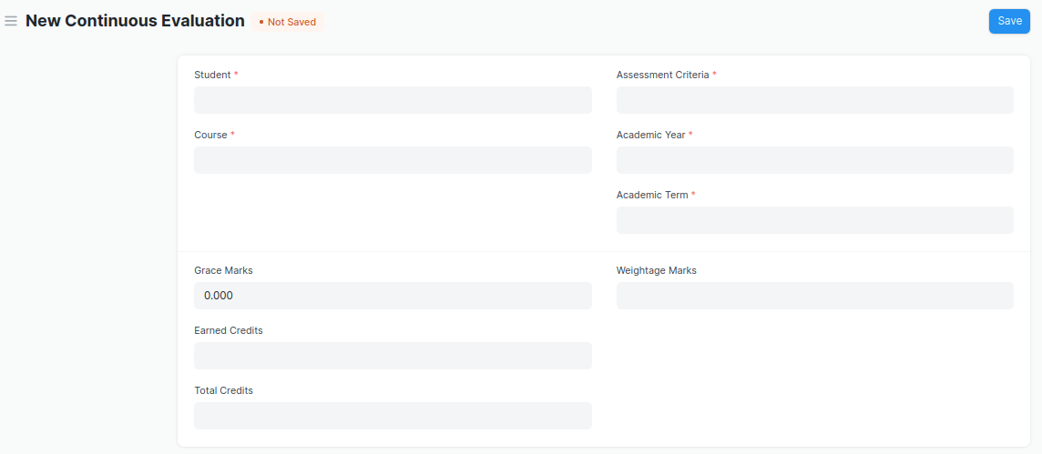

Figure 11 : Continuous Evaluation Screen

### **Continuous Evaluation Field Type:**

The “Continuous Evaluation” screen shall consist of the following fields:

|  |  |  |  |  |  |
| --- | --- | --- | --- | --- | --- |
| **Field Label** | **Field Type** | **Validation/Action** | **Mandatory** | **Remarks** | **R/N/D** |
| Student | Link Field | Fetched from student master screen | Y |  |  |
| Student Name | Text Field | Auto fetch based on Student |  |  |  |
| Course | Link Field | Fetched from Course master screen | Y |  | (R) Module |
| Roll No | Text Field | Auto fetch based on Student |  |  |  |
| Registration Number | Text Field | Auto fetch based on Student |  |  |  |
| Course Code | Text Field | Auto fetch based on Course |  |  | (R) Module Code |
| Course Name | Text Field | Auto fetch based on Course |  |  | (R) Module Name |
| Assessment Criteria | Link Field | Fetched from Assessment Criteria master screen | Y |  |  |
| Academic Year | Link Field | Fetched from Academic Year master screen | Y |  |  |
| Academic Term | Link Field | Fetched from Academic Term master screen | Y |  |  |
| Get Assessments | Button | User Input |  |  |  |
| **Final Credit Item** | Table | Child Table: Final Credit Item | Y |  |  |
| Grace Marks | Float | Fetched from Program Grades master screen |  |  |  |
| Earned Credits | Float | Fetched from Programs master screen |  |  |  |
| Total Credits | Float | Fetched from Program master screen |  |  |  |
| Weightage Marks | Float | Fetched from Exam Assessment Plan master screen |  |  |  |
| Final Marks | Float |  | Y |  |  |
| Out of Marks | Float |  |  |  |  |

|  |  |  |  |  |  |
| --- | --- | --- | --- | --- | --- |
| **Final Credit Item** | | | | | |
| **Field Label** | **Field Type** | **Validation/Action** | **Mandatory** | **Remarks** | **R/N/D** |
| Course Assessment | Link Field | Fetched from Course Assessment master screen |  |  |  |
| Earned Marks | Float |  |  |  |  |
| Grace Marks | Float |  |  |  |  |
| Total Marks | Float |  |  |  |  |

### **User: Roles & Permission**

The following table describes the users and their roles and permissions for the screens :

|  |  |  |  |  |  |  |  |  |  |
| --- | --- | --- | --- | --- | --- | --- | --- | --- | --- |
| **ID** | **Role** | **Select** | **Read** | **Write** | **Create** | **Delete** | **Submit** | **Cancel** | **Amend** |
| 1 | Admin | Yes | Yes | Yes | Yes | Yes | Yes | Yes | Yes |
| 2 | Instructor | Yes | Yes | Yes | Yes | No | Yes | No | No |
| 3 | Student | No | Yes | No | No | No | No | No | No |

## **2.7 Continuous Evaluation Tool**

|  |  |
| --- | --- |
| **Description :** | Continuous Evaluation is used to assess the Assessment Criteria done for a course for an individual student. |
| **Navigation :** | Home > Examination > Tools > Continuous Evaluation Tool |
| **Pre-requisites :** | Criteria Wise Evaluation |
| **Existing Screen Name :** |  |
| **New Screen Name :** |  |

### Continuous Evaluation Tool Screenshot:

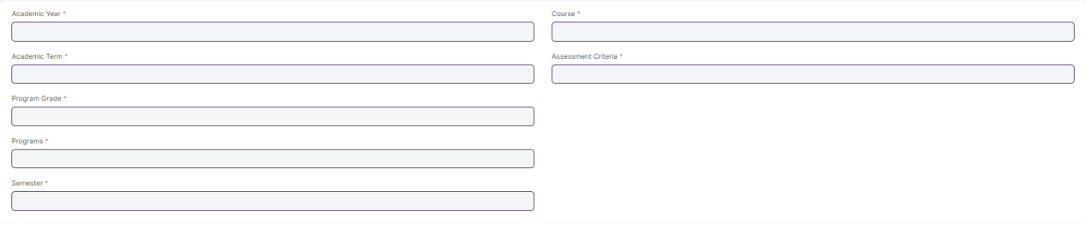

Figure 12 : Continuous Evaluation Screen

### **Continuous Evaluation Tool Field Type:**

The “Continuous Evaluation Tool” screen shall consist of the following fields:

|  |  |  |  |  |  |
| --- | --- | --- | --- | --- | --- |
| **Field Label** | **Field Type** | **Validation/Action** | **Mandatory** | **Remarks** | **R/N/D** |
| Academic Year | Link Field | Fetched from Academic Year master screen | Y |  |  |
| Academic Term | Link Field | Fetched from Academic Term master screen | Y |  |  |
| Program Grade | Link Field | Fetched from Program Grades master screen | Y |  | (R) Course Grade |
| Programs | Link Field | Fetched from Programs master screen |  |  | (R) Courses |
| Semester | Link Field | Fetched from Program master screen |  |  |  |
| Course | Link Field | Fetched from Course master screen | Y |  | (R) Module |
| Course Code | Text Field | Auto fetch based on Course |  |  | (R) Module Code |
| Course Name | Text Field | Auto fetch based on Course |  |  | (R) Module Name |
| Assessment Criteria | Link Field | Fetched from Assessment Criteria master screen | Y |  |  |
| Student Inputs | HTML |  |  |  |  |

### **User: Roles & Permission**

The following table describes the users and their roles and permissions for the screens :

|  |  |  |  |  |  |  |  |  |  |
| --- | --- | --- | --- | --- | --- | --- | --- | --- | --- |
| **ID** | **Role** | **Select** | **Read** | **Write** | **Create** | **Delete** | **Submit** | **Cancel** | **Amend** |
| 1 | Admin | Yes | Yes | Yes | Yes | Yes | Yes | Yes | Yes |
| 2 | Instructor | No | Yes | No | No | No | No | No | No |
| 3 | Student | No | Yes | No | No | No | No | No | No |

## 2.8 Final Exam Result

|  |  |
| --- | --- |
| **Description :** | Final Exam Result is used to evaluate the final assessment of a student for a particular semester. |
| **Navigation :** | Home > Examination > Evaluation > Final Exam Result |
| **Pre-requisites :** | Continuous Evaluation |
| **Existing Screen Name :** |  |
| **New Screen Name :** |  |

### Final Exam Result Screenshot:

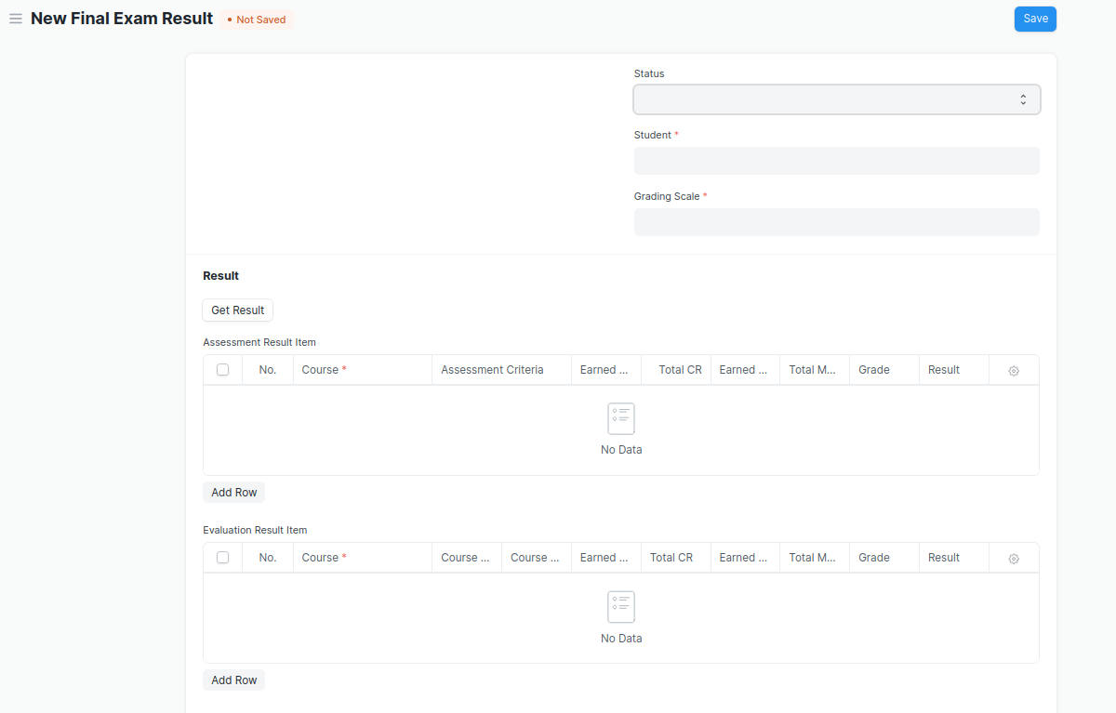

Figure 13 : Final Exam Result Screen

### Final Exam Result **Field Type:**

|  |  |  |  |  |  |
| --- | --- | --- | --- | --- | --- |
| **Field Label** | **Field Type** | **Validation/Action** | **Mandatory** | **Remarks** | **R/N/D** |
| Programs | Link Field | Auto fetch when Student Id is entered |  |  | (R) Courses |
| Semester | Link Field | Need to be entered manually. |  |  |  |
| Course | Link Field | Auto fetch when Student Id is entered |  |  | (R) Module |
| Academic Year | Link Field | Auto fetch when Student Id is entered |  |  |  |
| Academic Term | Link Field | Need to be entered manually |  |  |  |
| Student | Link Field | Fetched from student master screen |  |  |  |
| Student Name | Text Field | Auto fetch when Student Id is entered |  |  |  |
| Roll No | Text Field | Auto fetch when Student Id is entered |  |  |  |
| Registration Number | Text Field | Auto fetch when Student Id is entered |  |  |  |
| Grading Scale | Link Field | Fetched from Grading Scale master screen |  |  |  |
| Assessment Status | Text Field |  |  |  |  |
| Get Result | Button |  |  |  |  |
| **Assessment Result Item** | Table | After Clicking on Get Result, the **Assessment Result Item** table will auto fetch**.** |  |  |  |
| **Evaluation Result Item** | Table | This table will visible when a record is in **Draft** Status |  |  |  |
| Result | Text Field | Auto Calculated after saving the record |  |  |  |
| Grade | Text Field | Auto Calculated after saving the record |  |  |  |
| Overall Grade | Text Field | Auto Calculated after saving the record |  |  |  |
| Comment | Small Text Field |  |  |  |  |

|  |  |  |  |  |  |
| --- | --- | --- | --- | --- | --- |
| **Assessment Result Item** | | | | | |
| **Field Label** | **Field Type** | **Validation/Action** | **Mandatory** | **Remarks** | **R/N/D** |
| Course | Link Field | Fetched from Course master screen | Y |  | (R) Module |
| Assessment Criteria | Link Field | Fetched from Assessment Criteria master screen |  |  |  |
| Earned CR | Float |  |  |  |  |
| Total CR | Float |  |  |  |  |
| Earned Marks | Float |  |  |  |  |
| Total Marks | Float |  |  |  |  |
| Grade | Text Field |  |  |  |  |
| Result | Drop down | P/F |  |  |  |

|  |  |  |  |  |  |
| --- | --- | --- | --- | --- | --- |
| **Evaluation Result Item (This table will visible when the record is in draft stage)** | | | | | |
| **Field Label** | **Field Type** | **Validation/Action** | **Mandatory** | **Remarks** | **R/N/D** |
| Course | Link Field | Fetched from Course master screen | Y |  | (R) Module |
| Course Code | Text Field | Auto fetch based on Course |  |  | (R) Module Code |
| Course Name | Text Field | Auto fetch based on Course |  |  | (R) Module Name |
| Earned CR | Float |  |  |  |  |
| Total CR | Text Field |  |  |  |  |
| Earned Marks | Text Field |  |  |  |  |
| Total Marks | Text Field |  |  |  |  |
| Grade | Text Field |  |  |  |  |
| Result | Drop down | P/F |  |  |  |

### **User: Roles & Permission**

The following table describes the users and their roles and permissions for the screens :

|  |  |  |  |  |  |  |  |  |
| --- | --- | --- | --- | --- | --- | --- | --- | --- |
| **Role** | **Select** | **Read** | **Write** | **Create** | **Delete** | **Submit** | **Cancel** | **Amend** |
| Admin | Yes | Yes | Yes | Yes | Yes | Yes | Yes | Yes |
| Instructor | Yes | Yes | Yes | Yes | No | Yes | No | No |
| Student | No | Yes | No | No | No | No | No | No |

## 2.9 Final Result Declaration Tool

|  |  |
| --- | --- |
| **Description :** | Final Result Declaration Tool is used to declare the final exam results for a particular group/batch of students in a semester. |
| **Navigation :** | Home > Examination > Tools > Final Result Declaration Tool |
| **Pre-requisites :** | Continuous Evaluation |
| **Existing Screen Name :** |  |
| **New Screen Name :** |  |

### Final Exam Result Declaration Tool Screenshot:

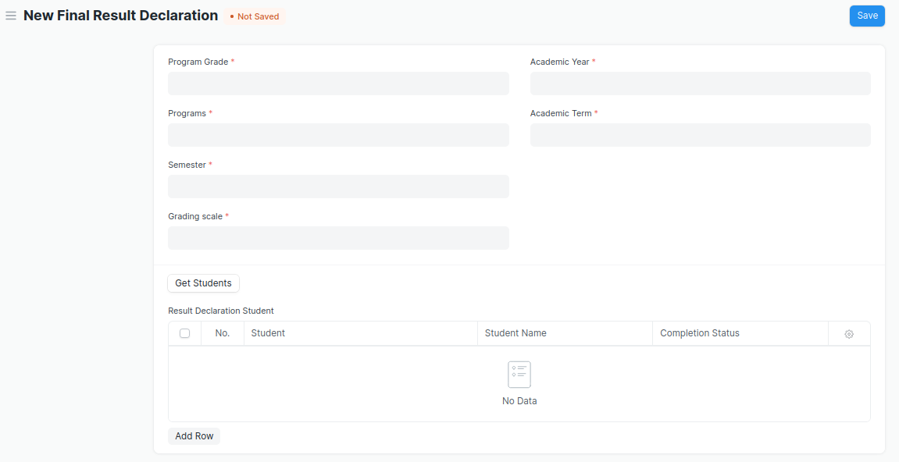

Figure 14 : Final Result Declaration Tool Screen

### Final Result Declaration Tool **Field Type:**

The “Final Result Declaration Tool” screen shall consist of the following fields:

|  |  |  |  |  |  |
| --- | --- | --- | --- | --- | --- |
| **Field Label** | **Field Type** | **Validation/Action** | **Mandatory** | **Remarks** | **R/N/D** |
| Program Grade | Link Field | Fetched from Program Grades master screen | Y |  |  |
| Programs | Link Field | Fetched from Programs master screen | Y |  |  |
| Semester | Link Field | Fetched from Program master screen | Y |  |  |
| Grading scale | Link Field | Fetched from Grading Scale master screen | Y |  |  |
| Academic Year | Link Field | Fetched from Academic Year master screen | Y |  |  |
| Academic Term | Link Field | Fetched from Academic Term master screen | Y |  |  |
| Result Creation Status | Drop Down | In Process  Failed  Successful |  |  |  |
| Get Students | Button | User Input |  |  |  |
| Total Enrolled Student | Int Field |  |  |  |  |
| Total Students for Result | Int Field |  |  |  |  |
| **Result Declaration Student** | Table | Child Table: Result Declaration Student |  |  |  |

|  |  |  |  |  |  |
| --- | --- | --- | --- | --- | --- |
| **Result Declaration Student** | | | | | |
| **Field Label** | **Field Type** | **Validation/Action** | **Mandatory** | **Remarks** | **R/N/D** |
| Student | Link Field | Fetched from Student master screen |  |  |  |
| Student Name | Text Field | Auto fetch based on Student |  |  |  |
| Completion Status | Drop down | Completed/Pending |  |  |  |
| Roll No | Text Field |  |  |  |  |

### **User: Roles & Permission**

The following table describes the users and their roles and permissions for the screens :

|  |  |  |  |  |  |  |  |  |
| --- | --- | --- | --- | --- | --- | --- | --- | --- |
| **Role** | **Select** | **Read** | **Write** | **Create** | **Delete** | **Submit** | **Cancel** | **Amend** |
| Admin | Yes | Yes | Yes | Yes | Yes | NA | NA | NA |
| Instructor | Yes | Yes | Yes | Yes | No | NA | NA | NA |
| Student | No | Yes | No | No | No | NA | NA | NA |

## 3.0 Cumulative Marksheet

|  |  |
| --- | --- |
| **Description :** | Cumulative Marksheet is a compilation of all the semesters with their grades in a single certificate. The Cumulative marksheet will have a list of subjects, grades obtained and CGPA (Cumulative Grade Point Average). And also details of students, such as roll number, name, age and date of birth, program enrollment. |
| **Navigation :** | Home > Examination > Transcripts > Cumulative Marksheet |
| **Pre-requisites :** | Final Exam Result |
| **Existing Screen Name :** |  |
| **New Screen Name :** |  |

### **Cumulative Marksheet Screenshot:**

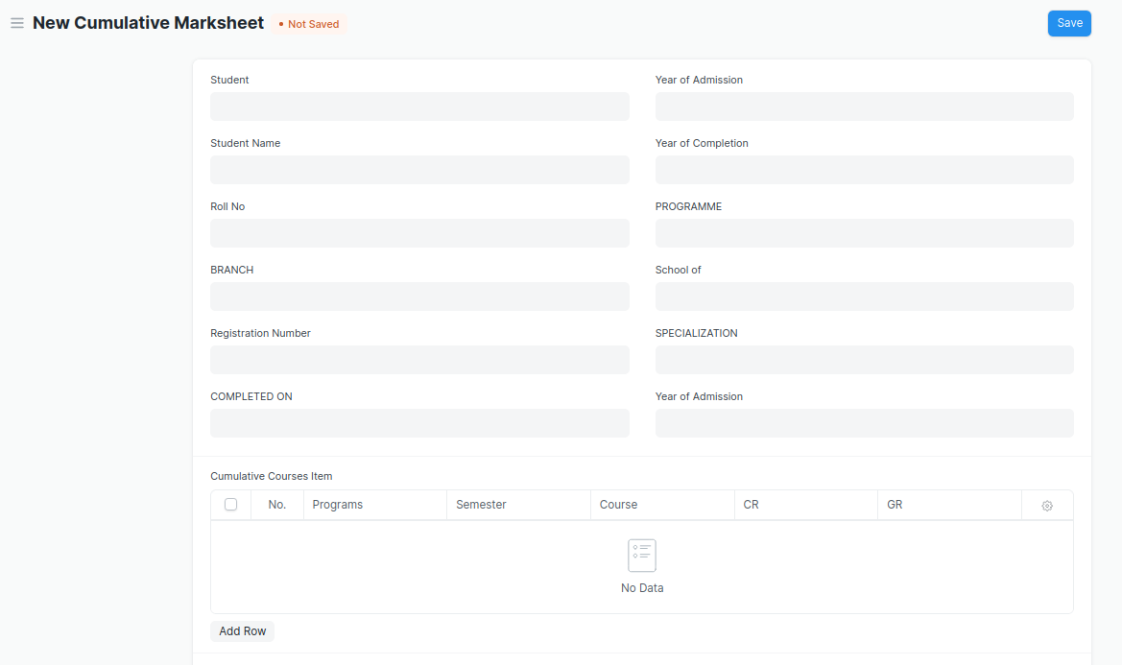

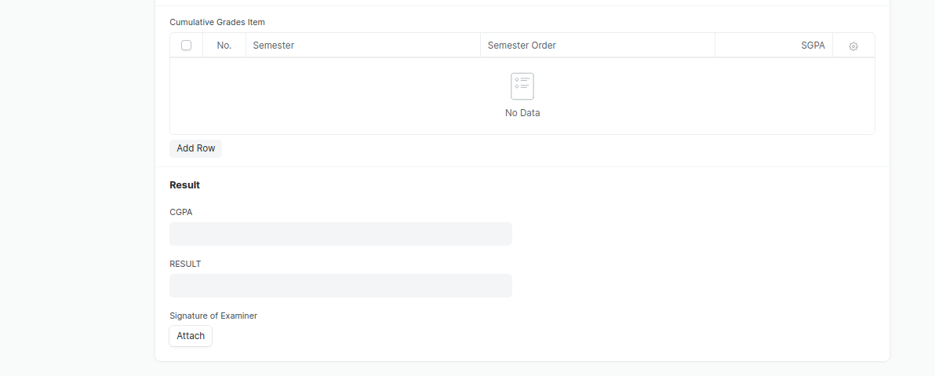

Figure 15 : Cumulative Marksheet Screen

* Remove/Hide the CGPA, SGPA, and Credit features from the Cumulative Mark sheet and display the percentage and grade instead.

### **Cumulative Marksheet Field Type:**

The “Cumulative Marksheet” screen shall consist of the following fields:

|  |  |  |  |  |  |
| --- | --- | --- | --- | --- | --- |
| **Field Label** | **Field Type** | **Validation/Action** | **Mandatory** | **Remarks** | **R/N/D** |
| Student | Link Field | Fetched from Student master screen |  |  |  |
| Student Name | Text Field | Auto fetch based on Student |  |  |  |
| Roll No | Text Field | Auto fetch based on Student |  |  |  |
| BRANCH | Text Field |  |  |  |  |
| Registration Number | Text Field | Auto fetch based on Student |  |  |  |
| COMPLETED ON | Text Field |  |  |  |  |
| Year of Admission | Link Field | Fetched from Academic Year master screen |  |  |  |
| Year of Completion | Link Field | Fetched from Academic Year master screen |  |  |  |
| PROGRAMME | Link Field | Fetched from Programs master screen |  |  |  |
| School of | Text Field |  |  |  |  |
| SPECIALIZATION | Text Field | Fetched from Academic Year master screen |  |  |  |
| Year of Admission | Text Field |  |  |  |  |
| **Cumulative Courses Item** | Table | Child Table: Cumulative Courses Item |  |  |  |
| **Cumulative Grades Item** | Table | Child Table: Cumulative Grades Item |  |  |  |
| Overall Grade | Float |  |  |  | D |
| RESULT | Text Field | User Input |  |  |  |
| Signature of Examiner | Attach image |  |  |  |  |

|  |  |  |  |  |  |
| --- | --- | --- | --- | --- | --- |
| **Cumulative Courses Item** | | | | | |
| **Field Label** | **Field Type** | **Validation/Action** | **Mandatory** | **Remarks** | **R/N/D** |
| Programs | Link Field | Fetched from Programs master screen |  |  |  |
| Semester | Link Field | Fetched from Program master screen |  |  |  |
| Course | Link Field | Fetched from Course master screen |  |  | (R) Module |
| Course Code | Text Field | Auto fetch based on Course |  |  | (R) Module Code |
| Course Name | Text Field | Auto fetch based on Course |  |  | (R) Module Name |
| CR | Text Field |  |  |  |  |
| GR | Text Field |  |  |  |  |

|  |  |  |  |  |  |
| --- | --- | --- | --- | --- | --- |
| **Cumulative Grades Item** | | | | | |
| **Field Label** | **Field Type** | **Validation/Action** | **Mandatory** | **Remarks** | **R/N/D** |
| Semester | Link Field | Fetched from Program master screen |  |  |  |
| Semester Order | Drop down | 1ST SEM  2ND SEM  3RD SEM  4TH SEM  5TH SEM  6TH SEM  7TH SEM  8TH SEM  9TH SEM  10TH SEM |  |  |  |
| Grade | Data |  |  |  | D |

### **User: Roles & Permission**

The following table describes the users and their roles and permissions for the screens :

|  |  |  |  |  |  |  |  |  |
| --- | --- | --- | --- | --- | --- | --- | --- | --- |
| **Role** | **Select** | **Read** | **Write** | **Create** | **Delete** | **Submit** | **Cancel** | **Amend** |
| Admin | Yes | Yes | Yes | Yes | Yes | NA | NA | NA |
| Instructor | Yes | Yes | Yes | Yes | No | NA | NA | NA |
| Student | No | Yes | No | No | No | NA | NA | NA |

## Cumulative Marksheet Tool

|  |  |
| --- | --- |
| **Description :** | Cumulative Marksheet is a compilation of all the semesters with their grades in a single certificate. The Cumulative marksheet will have a list of subjects, grades obtained and CGPA (Cumulative Grade Point Average). And also details of students, such as roll number, name, age and date of birth, program enrollment. |
| **Navigation :** | Home > Examination > Tools > Cumulative Marksheet Tool |
| **Pre-requisites :** | Final Exam Result |
| **Existing Screen Name :** |  |
| **New Screen Name :** |  |

### **Cumulative Marksheet Tool Screenshot:**

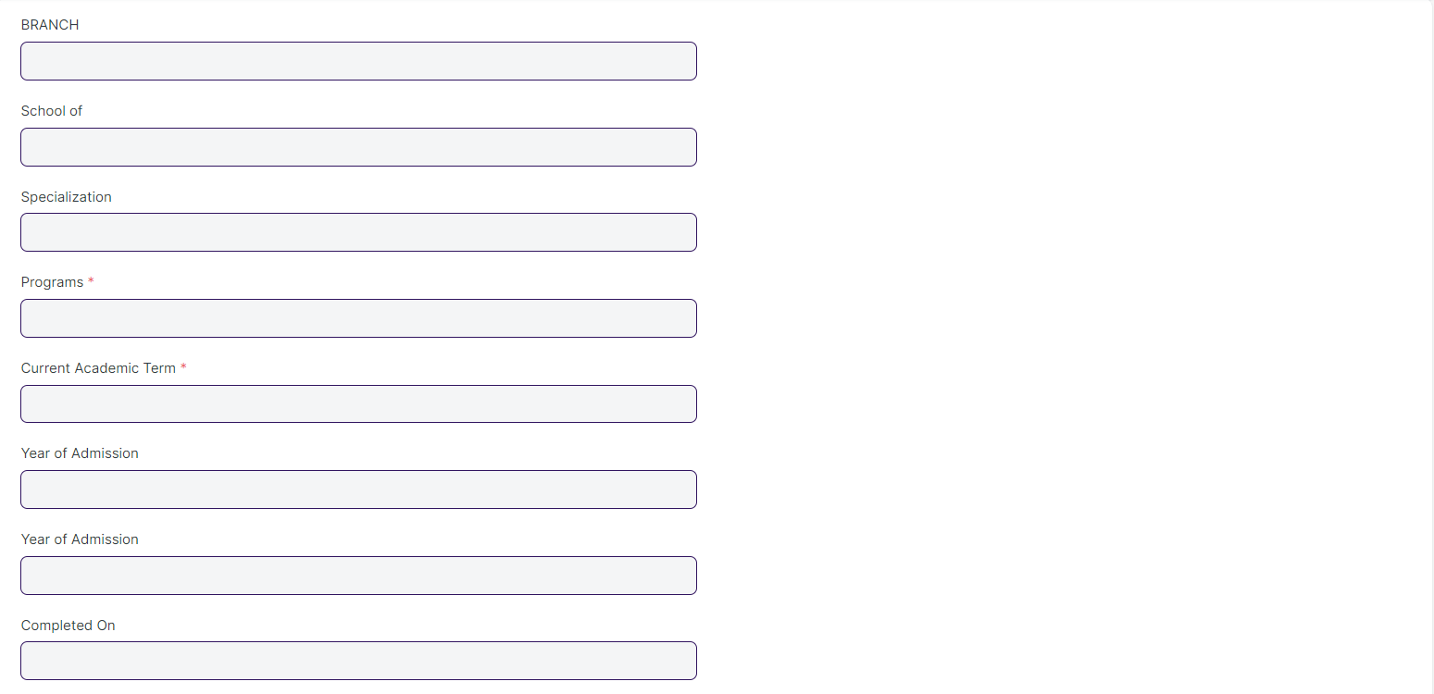

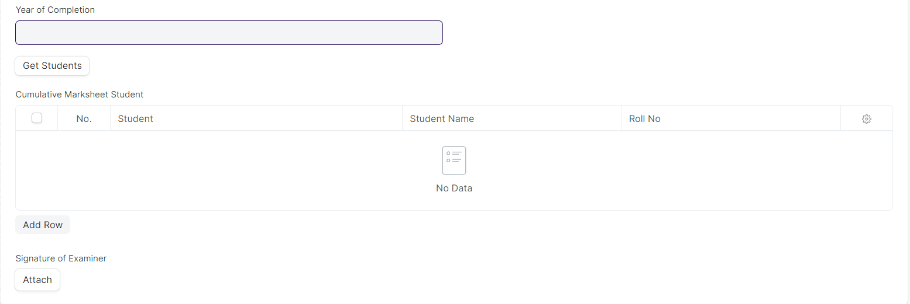

Figure 16 : Cumulative Marksheet Tool

* Remove/Hide the CGPA, SGPA, and Credit features from the Cumulative Mark sheet and display the percentage and grade instead.

### Cumulative Marksheet Tool **Field Type:**

The “Cumulative Marksheet Tool” screen shall consist of the following fields:

|  |  |  |  |  |  |
| --- | --- | --- | --- | --- | --- |
| **Field Label** | **Field Type** | **Validation/Action** | **Mandatory** | **Remarks** | **R/N/D** |
| BRANCH | Text Field |  |  |  |  |
| School of | Text Field |  |  |  |  |
| Specialization | Text Field |  |  |  |  |
| Programs | Link Field | Fetched from Programs master screen | Y |  |  |
| Current Academic Term | Link Field | Fetched from Academic Term master screen | Y |  |  |
| Year of Admission | Link Field | Fetched from Academic Year master screen |  |  |  |
| Year of Admission | Text Field |  |  |  |  |
| COMPLETED ON | Text Field |  |  |  |  |
| Year of Completion | Link Field | Fetched from Academic Year master screen |  |  |  |
| Result Creation Status | Dropdown | In Process/Failed/  Successful |  |  |  |
| Get Students | Button | Student will fetch based on Programs & Academic Term |  |  |  |
| Total Students for Marksheet | Int |  |  |  |  |
| Cumulative Marksheet Student | Table | Child Table: Cumulative Marksheet Student |  |  |  |
| Signature of Examiner | Attach | Examiner Signature Attachment |  |  |  |

|  |  |  |  |  |  |
| --- | --- | --- | --- | --- | --- |
| **Cumulative Marksheet Student** | | | | | |
| **Field Label** | **Field Type** | **Validation/Action** | **Mandatory** | **Remarks** | **R/N/D** |
| Student | Link Field | Fetched from “Get Students” Button |  |  |  |
| Student Name | Text Field | Auto fetch based on Student |  |  |  |
| Roll No | Text Field | Auto fetch based on Student |  |  |  |
| Registration Number | Text Field | Auto fetch based on Student |  |  |  |

### **User: Roles & Permission**

The following table describes the users and their roles and permissions for the screens :

|  |  |  |  |  |  |  |  |  |
| --- | --- | --- | --- | --- | --- | --- | --- | --- |
| **Role** | **Select** | **Read** | **Write** | **Create** | **Delete** | **Submit** | **Cancel** | **Amend** |
| Admin | Yes | Yes | Yes | Yes | Yes | NA | NA | NA |
| Instructor | Yes | Yes | Yes | Yes | No | NA | NA | NA |
| Student | No | Yes | No | No | No | NA | NA | NA |

## Leaving Certificate

|  |  |
| --- | --- |
| **Description :** | Leaving Certificate is issued when the students have completed their programs. In the ERP the leaving certificate is issued when their Assessment Status is complete. It is a certificate showing a person has completed his or her time at school, sometimes requiring the passing of an exam or exams. |
| **Navigation :** | Home > Examination > Transcripts > Leaving Certificate |
| **Pre-requisites :** | The Student should have completed his/her respective program. |
| **Existing Screen Name :** |  |
| **New Screen Name :** |  |

### Leaving Certificate **Screenshot:**

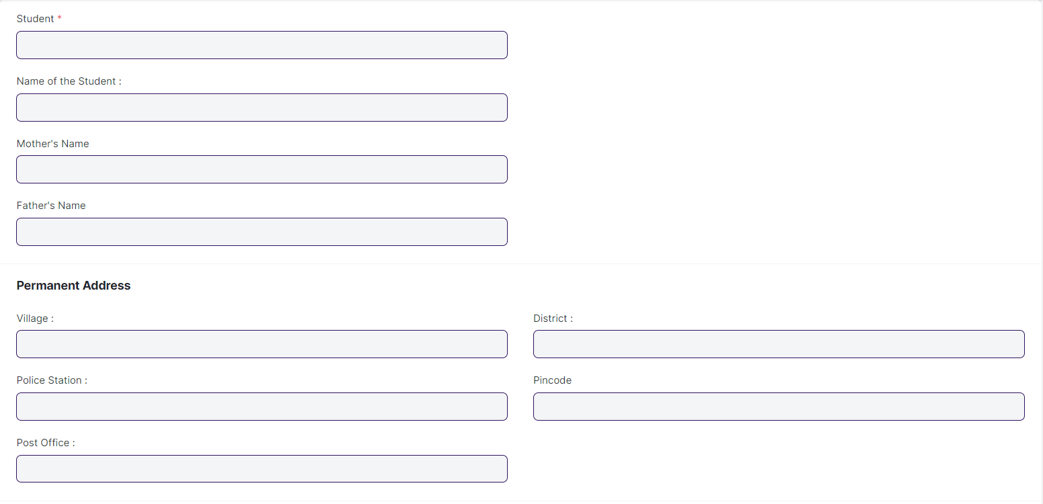

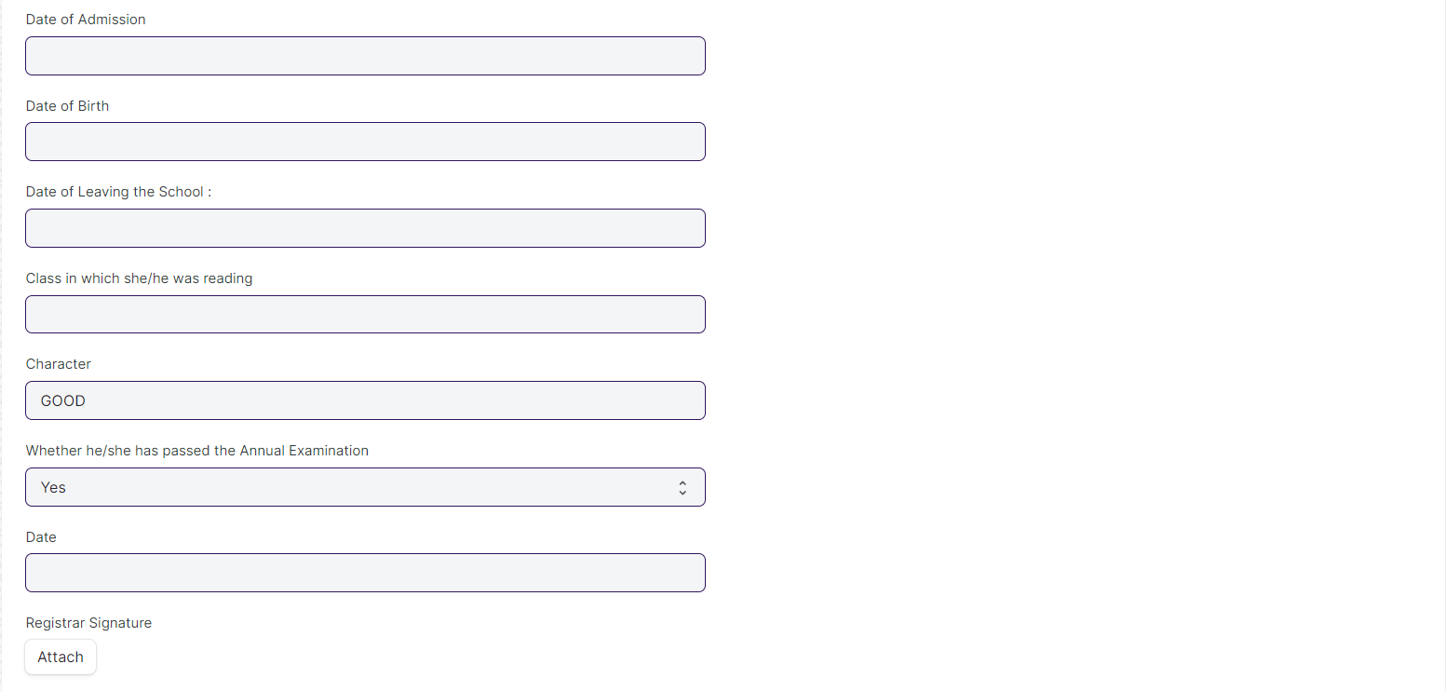

Figure 17 : Leaving Certificate Screen

### Leaving Certificate **Field Type:**

The “Leaving Certificate” screen shall consist of the following fields:

|  |  |  |  |  |  |
| --- | --- | --- | --- | --- | --- |
| **Field Label** | **Field Type** | **Validation/Action** | **Mandatory** | **Remarks** | **R/N/D** |
| Student | Link Field | Fetched from Student master screen | Y |  |  |
| Name of the Student : | Text Field | Auto fetch based on Student |  |  |  |
| Roll No | Text Field | Auto fetch based on Student |  |  |  |
| Mother's Name | Text Field | Auto fetch based on Student |  |  |  |
| Father's Name | Text Field | Auto fetch based on Student |  |  |  |
| Village : | Text Field | Auto fetch based on Student |  |  |  |
| Police Station : | Text Field | Auto fetch based on Student |  |  |  |
| Post Office : | Text Field | Auto fetch based on Student |  |  |  |
| District : | Text Field | Auto fetch based on Student |  |  |  |
| Pincode | Text Field | Auto fetch based on Student |  |  |  |
| Date of Admission | Text Field |  |  |  |  |
| Date of Birth | Date |  |  |  |  |
| Date of Leaving the School : | Text Field |  |  |  |  |
| Class in which she/he was reading | Link Field |  |  |  |  |
| Character | Text Field |  |  |  |  |
| Whether he/she has passed the Annual Examination | Drop Down | Yes  No |  |  |  |
| Date | Date Picker | User Input |  |  |  |
| Registrar Signature | Attach Image | User Input |  |  |  |

### **User: Roles & Permission**

The following table describes the users and their roles and permissions for the screens :

|  |  |  |  |  |  |  |  |  |
| --- | --- | --- | --- | --- | --- | --- | --- | --- |
| **Role** | **Select** | **Read** | **Write** | **Create** | **Delete** | **Submit** | **Cancel** | **Amend** |
| Admin | Yes | Yes | Yes | Yes | Yes | NA | NA | NA |
| Instructor | No | Yes | No | No | No | NA | NA | NA |
| Student | No | Yes | No | No | No | NA | NA | NA |

## Leaving Certificate Tool

|  |  |
| --- | --- |
| **Description :** | Leaving Certificate is issued when the students have completed their programs. In the ERP the leaving certificate is issued when their Assessment Status is complete. It is a certificate showing a person has completed his or her time at school, sometimes requiring the passing of an exam or exams. |
| **Navigation :** | Home > Examination > Tools > Leaving Certificate Tool |
| **Pre-requisites :** |  |
| **Existing Screen Name :** |  |
| **New Screen Name :** |  |

### Leaving Certificate **Tool Screenshot:**

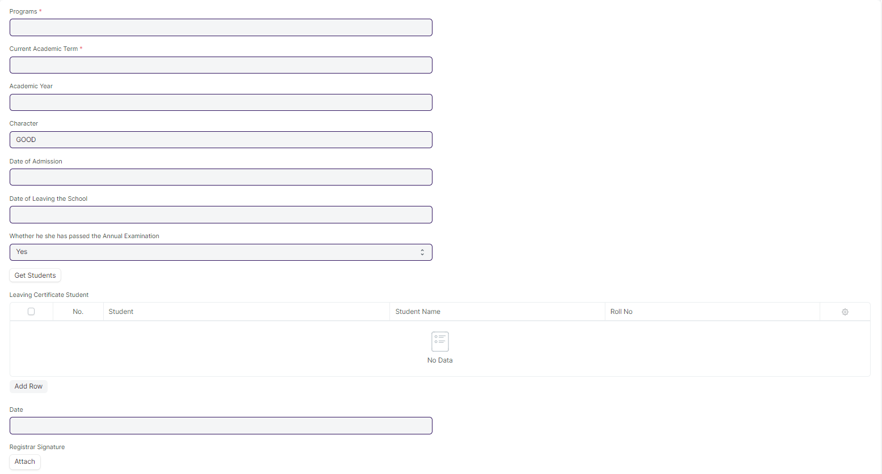

Figure 18 : Leaving Certificate Tool

### Leaving Certificate **Field Type:**

The “Leaving Certificate Tool” screen shall consist of the following fields:

|  |  |  |  |  |  |
| --- | --- | --- | --- | --- | --- |
| **Field Label** | **Field Type** | **Validation/Action** | **Mandatory** | **Remarks** | **R/N/D** |
| Programs | Link Field | Fetched from Programs master screen | Y |  | (R) Course |
| Current Academic Term | Link Field | Fetched from Academic Term master screen |  |  |  |
| Academic Year | Link Field | Fetched from Academic Year master screen |  |  |  |
| Academic Year Start | Date |  |  |  |  |
| Character | Text Field | Default:GOOD |  |  |  |
| Date of Admission | Text Field |  |  |  |  |
| Date of Leaving the School | Text Field |  |  |  |  |
| Whether he she has passed the Annual Examination | Dropdown | Yes/No |  |  |  |
| Academic Year End | Date | Auto fetch based on Student |  |  |  |
| Certificate Creation Status | Dropdown | Auto fetch based on Student |  |  |  |
| Get Students | Button |  |  |  |  |
| Total Students for Certificate | Int |  |  |  |  |
| Leaving Certificate Student | Table |  |  |  |  |
| Date | Date Picker | User Input |  |  |  |
| Registrar Signature | Attach Image | User Input |  |  |  |

|  |  |  |  |  |  |  |  |  |  |  |  |
| --- | --- | --- | --- | --- | --- | --- | --- | --- | --- | --- | --- |
| **Leaving Certificate Student** | | | | | | | | | | | |
| **Field Label** | **Field Type** | | **Validation/Action** | | **Mandatory** | | **Remarks** | | **R/N/D** | |
| Student | | Link Field | | Fetched from Get Students Button | |  | |  | |  | |
| Student Name | | Text Field | | Auto fetch based on Student | |  | |  | |  | |
| Roll No | | Text Field | | Auto fetch based on Student | |  | |  | |  | |
| Registration Number | | Text Field | | Auto fetch based on Student | |  | |  | |  | |

### **User: Roles & Permission**

The following table describes the users and their roles and permissions for the screens :

|  |  |  |  |  |  |  |  |  |
| --- | --- | --- | --- | --- | --- | --- | --- | --- |
| **Role** | **Select** | **Read** | **Write** | **Create** | **Delete** | **Submit** | **Cancel** | **Amend** |
| Admin | Yes | Yes | Yes | Yes | Yes | NA | NA | NA |
| Instructor | No | Yes | No | No | No | NA | NA | NA |
| Student | No | Yes | No | No | No | NA | NA | NA |

## 3.4 Provisional Certificate

|  |  |
| --- | --- |
| **Description :** | Provisional Certificate is issued in order to make sure that the  student is not deprived of any future opportunities in the form of a job or higher education. It helps the college administration in keeping a record of students who have passed from the university. |
| **Navigation :** | Home > Examination > Transcripts >Provisional Certificate |
| **Pre-requisites :** |  |
| **Existing Screen Name :** |  |
| **New Screen Name :** |  |

### **Provisional Certificate Screenshot:**

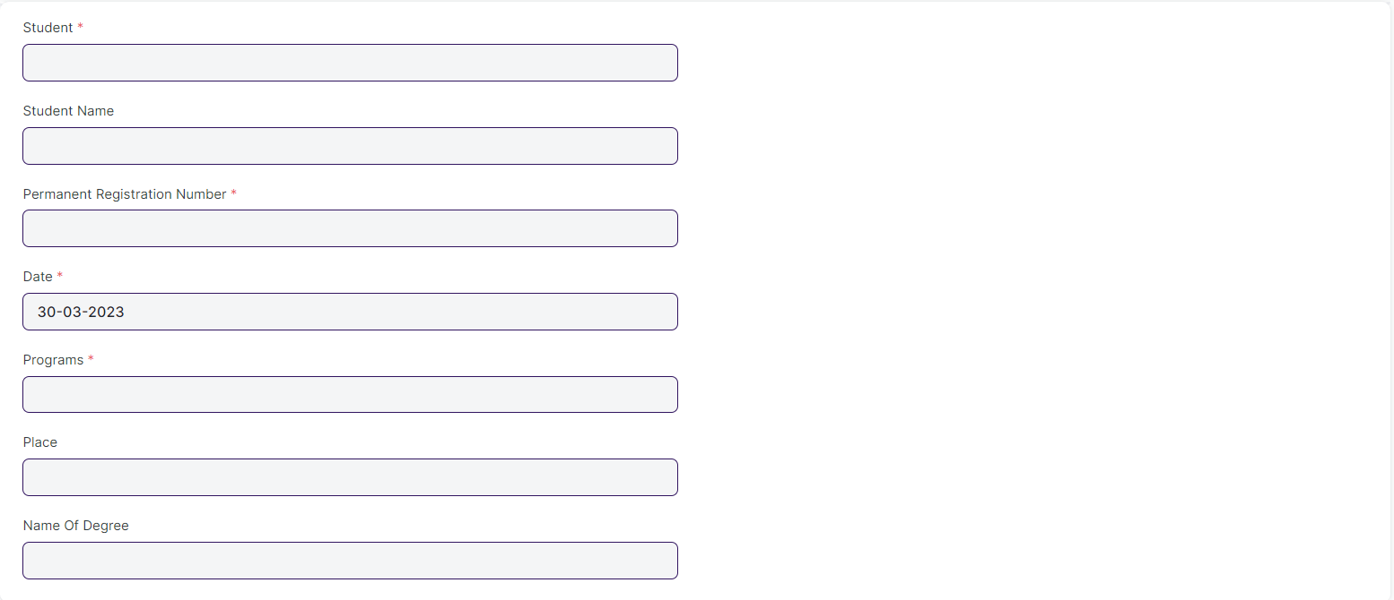

Figure 19 : Provisional Certificate

### Provisional Certificate **Field Type:**

The “Provisional Certificate” screen shall consist of the following fields:

|  |  |  |  |  |  |
| --- | --- | --- | --- | --- | --- |
| **Field Label** | **Field Type** | **Validation/Action** | **Mandatory** | **Remarks** | **R/N/D** |
| Student | Link Field | Fetched from Student master screen | Y |  |  |
| Student Name | Text Field | Auto fetch based on Student |  |  |  |
| Roll No | Text Field | Auto fetch based on Student |  |  |  |
| Permanent Registration Number | Text Field | Auto fetch based on Student | Y |  |  |
| Date | Date | Today’s date is fetched | Y |  |  |
| Programs | Link Field | Fetched from Programs master screen | Y |  |  |
| Place | Text Field |  |  |  |  |
| Name Of Degree | Text Field |  |  |  |  |

### **User: Roles & Permission**

The following table describes the users and their roles and permissions for the screens :

|  |  |  |  |  |  |  |  |  |
| --- | --- | --- | --- | --- | --- | --- | --- | --- |
| **Role** | **Select** | **Read** | **Write** | **Create** | **Delete** | **Submit** | **Cancel** | **Amend** |
| Admin | Yes | Yes | Yes | Yes | Yes | NA | NA | NA |
| Instructor | No | Yes | No | No | No | NA | NA | NA |
| Student | No | Yes | No | No | No | NA | NA | NA |

## 3.5 Provisional Certificate Tool

|  |  |
| --- | --- |
| **Description :** | Provisional Certificate is issued in order to make sure that the  student is not deprived of any future opportunities in the form of a job or higher education. It helps the college administration in keeping a record of students who have passed from the university. |
| **Navigation :** | Home > Examination > Tools > Provisional Certificate Tool |
| **Pre-requisites :** |  |
| **Existing Screen Name :** |  |
| **New Screen Name :** |  |

### Provisional Certificate Tool Screenshot:

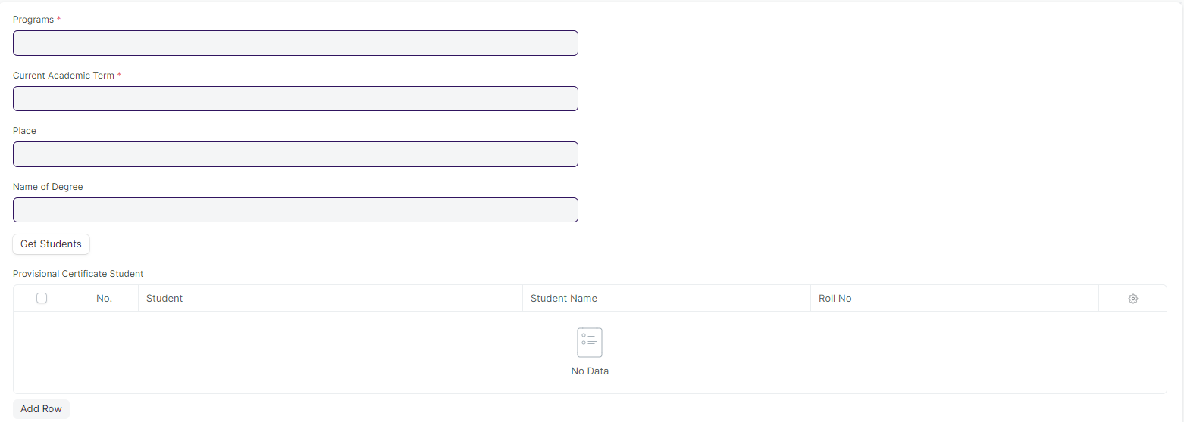

Figure 20 : Provisional Certificate Tool

### **Provisional Certificate Tool Field Type:**

The “Provisional Certificate Tool” screen shall consist of the following fields:

|  |  |  |  |  |  |
| --- | --- | --- | --- | --- | --- |
| **Field Label** | **Field Type** | **Validation/Action** | **Mandatory** | **Remarks** | **R/N/D** |
| Programs | Link Field | Fetched from Programs master screen | Y |  | (R) Course |
| Current Academic Term | Link Field | Fetched from Academic Term master screen | Y |  |  |
| Place | Text Field |  |  |  |  |
| Name of Degree | Text Field |  |  |  |  |
| Certificate Creation Status | Dropdown | In Process  Failed  Successful |  |  |  |
| Get Students | Button |  |  |  |  |
| Total Students for Certificate | Int |  |  |  |  |
| Provisional Certificate Student | Table |  |  |  |  |

|  |  |  |  |  |  |
| --- | --- | --- | --- | --- | --- |
| **Provisional Certificate Student** | | | | | |
| **Field Label** | **Field Type** | **Validation/Action** | **Mandatory** | **Remarks** | **R/N/D** |
| Student | Link Field | Fetched from Get Students Button |  |  |  |
| Student Name | Text Field | Auto fetch based on Student |  |  |  |
| Roll No | Text Field | Auto fetch based on Student |  |  |  |
| Registration Number | Text Field | Auto fetch based on Student |  |  |  |

### **User: Roles & Permission**

The following table describes the users and their roles and permissions for the screens :

|  |  |  |  |  |  |  |  |  |
| --- | --- | --- | --- | --- | --- | --- | --- | --- |
| **Role** | **Select** | **Read** | **Write** | **Create** | **Delete** | **Submit** | **Cancel** | **Amend** |
| Admin | Yes | Yes | Yes | Yes | Yes | NA | NA | NA |
| Instructor | No | Yes | No | No | No | NA | NA | NA |
| Student | No | Yes | No | No | No | NA | NA | NA |

## 3.6 Migration Certificate

|  |  |
| --- | --- |
| **Description :** | Migration Certificate is a document issued by the concerned University or Board in which one studies. It helps in getting admission to another institution or any education board and it is issued at the completion of the course along with other necessary documents. |
| **Navigation :** | Home > Examination > Transcripts >Migration Certificate |
| **Pre-requisites :** |  |
| **Existing Screen Name :** |  |
| **New Screen Name :** |  |

### Migration Certificate Screenshot:

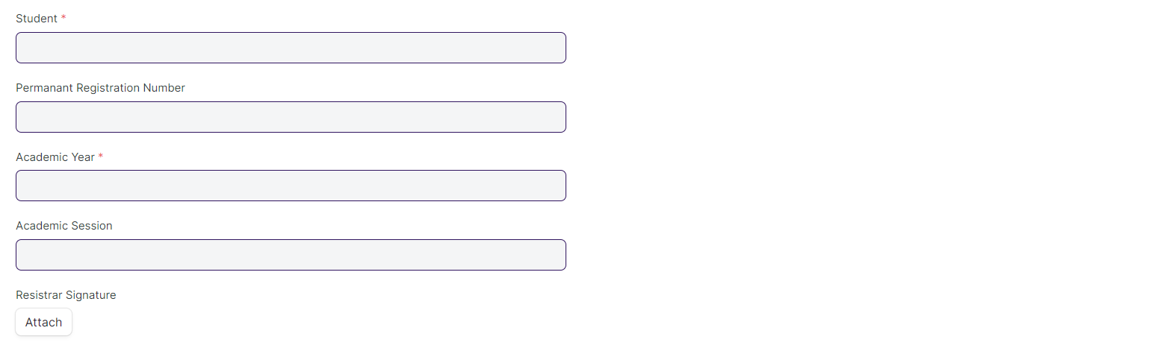

Figure 21 : Migration Certificate Screen

### Migration Certificate Field Type:

The “Migration Certificate” screen shall consist of the following fields:

|  |  |  |  |  |  |
| --- | --- | --- | --- | --- | --- |
| **Field Label** | **Field Type** | **Validation/Action** | **Mandatory** | **Remarks** | **R/N/D** |
| Student | Link Field | Fetched from Student master screen | Y |  |  |
| Student Name | Text Field | Auto fetch based on Student |  |  |  |
| Roll No | Text Field | Auto fetch based on Student |  |  |  |
| Permanent Registration Number | Text Field | Auto fetch based on Student |  |  |  |
| Programs | Link Field | Fetched from Programs master screen |  |  |  |
| Academic Year | Link Field | Fetched from Academic Year master screen | Y |  |  |
| Academic Session | Text Field |  |  |  |  |
| Registrar Signature | Attach Image | User Input |  |  |  |

### **User: Roles & Permission**

The following table describes the users and their roles and permissions for the screens :

|  |  |  |  |  |  |  |  |  |
| --- | --- | --- | --- | --- | --- | --- | --- | --- |
| **Role** | **Select** | **Read** | **Write** | **Create** | **Delete** | **Submit** | **Cancel** | **Amend** |
| Admin | Yes | Yes | Yes | Yes | Yes | NA | NA | NA |
| Instructor | No | Yes | No | No | No | NA | NA | NA |
| Student | No | Yes | No | No | No | NA | NA | NA |

## 3.7 Migration Certificate Tool

|  |  |
| --- | --- |
| **Description :** | Migration Certificate is a document issued by the concerned University or Board in which one studies. It helps in getting admission to another institution or any education board and it is issued at the completion of the course along with other necessary documents. |
| **Navigation :** | Home > Examination > Tools > Migration Certificate Tool |
| **Pre-requisites :** |  |
| **Existing Screen Name :** |  |
| **New Screen Name :** |  |

### Migration Certificate Tool Screenshot :

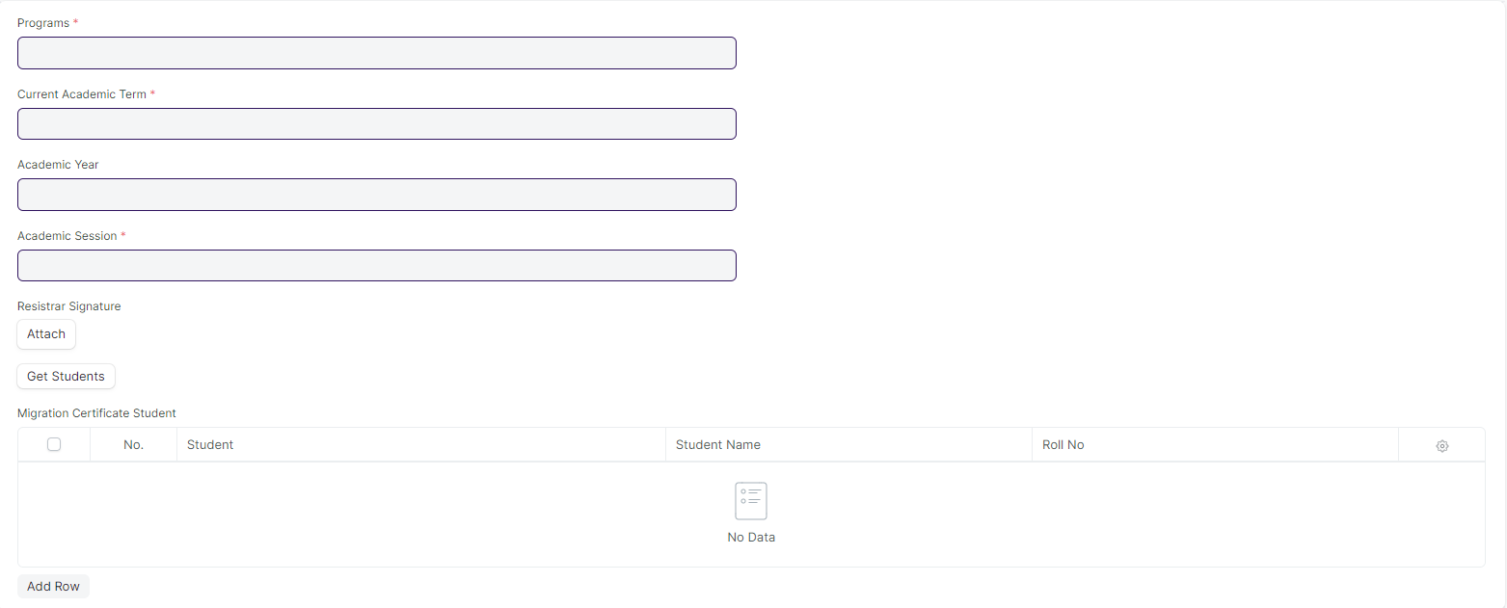

Figure 22 : Migration Certificate Tool Screen

### Migration Certificate Tool Field Type:

The “Migration Certificate Tool” screen shall consist of the following fields:

|  |  |  |  |  |  |
| --- | --- | --- | --- | --- | --- |
| **Field Label** | **Field Type** | **Validation/Action** | **Mandatory** | **Remarks** | **R/N/D** |
| Programs | Link Field | Fetched from Programs master screen | Y |  | (R) Courses |
| Current Academic Term | Link Field | Fetched from Academic Term master screen |  |  |  |
| Academic Year | Link Field | Fetched from Academic Year master screen | Y |  |  |
| Registrar Signature | Attach |  |  |  |  |
| Certificate Creation Status | Dropdown | In Process  Failed  Successful |  |  |  |
| Get Students | Button |  |  |  |  |
| Total Students for Certificate | Int |  |  |  |  |
| Migration Certificate Student | Table |  |  |  |  |

|  |  |  |  |  |  |
| --- | --- | --- | --- | --- | --- |
| **Migration Certificate Student** | | | | | |
| **Field Label** | **Field Type** | **Validation/Action** | **Mandatory** | **Remarks** | **R/N/D** |
| Student | Link Field | Fetched from Get Students Button |  |  |  |
| Student Name | Data | Auto fetch based on Student |  |  |  |
| Roll No | Data | Auto fetch based on Student |  |  |  |
| Registration Number | Data | Auto fetch based on Student |  |  |  |

### **User: Roles & Permission**

The following table describes the users and their roles and permissions for the screens :

|  |  |  |  |  |  |  |  |  |
| --- | --- | --- | --- | --- | --- | --- | --- | --- |
| **Role** | **Select** | **Read** | **Write** | **Create** | **Delete** | **Submit** | **Cancel** | **Amend** |
| Admin | Yes | Yes | Yes | Yes | Yes | NA | NA | NA |
| Instructor | No | Yes | No | No | No | NA | NA | NA |
| Student | No | Yes | No | No | No | NA | NA | NA |

## 3.8 Conduct Certificate

|  |  |
| --- | --- |
| **Description :** | A Conduct Certificate specifies the behavior of an individual during a period of time, in an official place. It is also sometimes referred to as a character certificate. A conduct certificate is given to a student when he wants to get admission in another institute or in case of transfer. |
| **Navigation :** | Home > Examination > Transcripts > Conduct Certificate |
| **Pre-requisites :** |  |
| **Existing Screen Name :** |  |
| **New Screen Name :** |  |

### Conduct Certificate Screenshot :

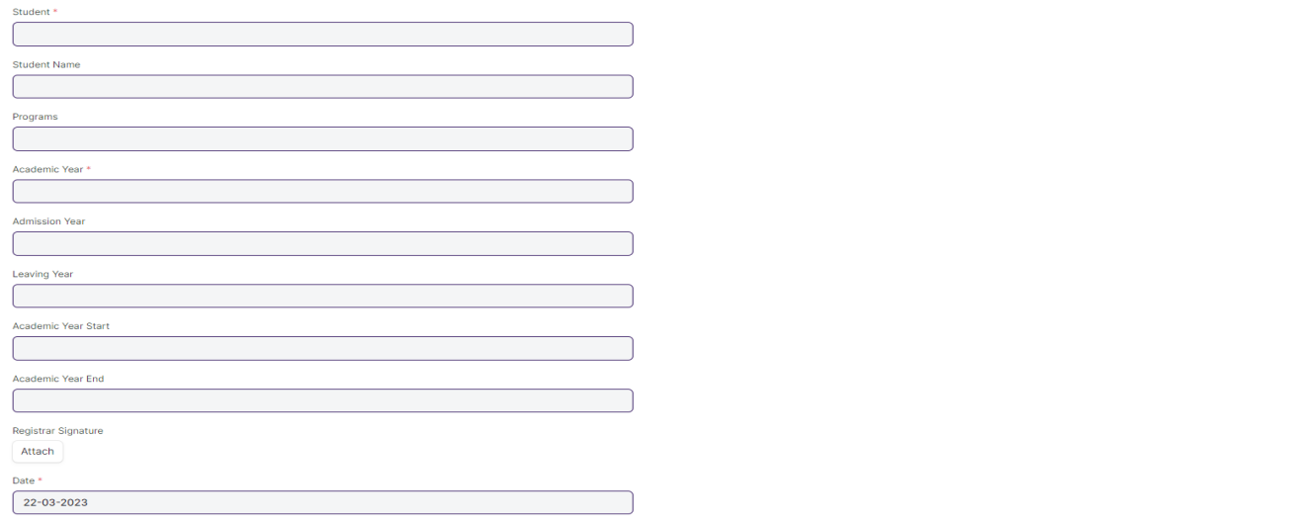

Figure 23 : Conduct Certificate Screen

### Conduct Certificate Field Type :

The “Conduct Certificate” screen shall consist of the following fields:

|  |  |  |  |  |  |
| --- | --- | --- | --- | --- | --- |
| **Field Label** | **Field Type** | **Validation/Action** | **Mandatory** | **Remarks** | **R/N/D** |
| Student | Link Field | Fetched from Student master screen | Y |  |  |
| Student Name | Text Field | Auto fetch based on Student |  |  |  |
| Roll No | Text Field | Auto fetch based on Student |  |  |  |
| Programs | Link Field | Fetched from Programs master screen |  |  | (R) Courses |
| Academic Year | Link Field | Fetched from Academic Year master screen | Y |  |  |
| Admission Year | Text Field |  |  |  |  |
| Leaving Year | Text Field |  |  |  |  |
| Academic Year Start | Date Picker |  |  |  |  |
| Academic Year End | Date Picker |  |  |  |  |
| Registrar Signature | Attach Image | User Input |  |  |  |
| Date | Date | Today’s date is fetched | Y |  |  |

### **User: Roles & Permission**

The following table describes the users and their roles and permissions for the screens :

|  |  |  |  |  |  |  |  |  |
| --- | --- | --- | --- | --- | --- | --- | --- | --- |
| **Role** | **Select** | **Read** | **Write** | **Create** | **Delete** | **Submit** | **Cancel** | **Amend** |
| Admin | Yes | Yes | Yes | Yes | Yes | NA | NA | NA |
| Instructor | No | Yes | No | No | No | NA | NA | NA |
| Student | No | Yes | No | No | No | NA | NA | NA |

## 3.9 Conduct Certificate Tool

|  |  |
| --- | --- |
| **Description :** | A Conduct Certificate specifies the behavior of an individual during a period of time, in an official place. It is also sometimes referred to as a character certificate. A conduct certificate is given to a student when he wants to get admission in another institute or in case of transfer. |
| **Navigation :** | Home > Examination > Tools > Conduct Certificate Tool |
| **Pre-requisites :** |  |
| **Existing Screen Name :** |  |
| **New Screen Name :** |  |

### Conduct Certificate Tool Screenshot :

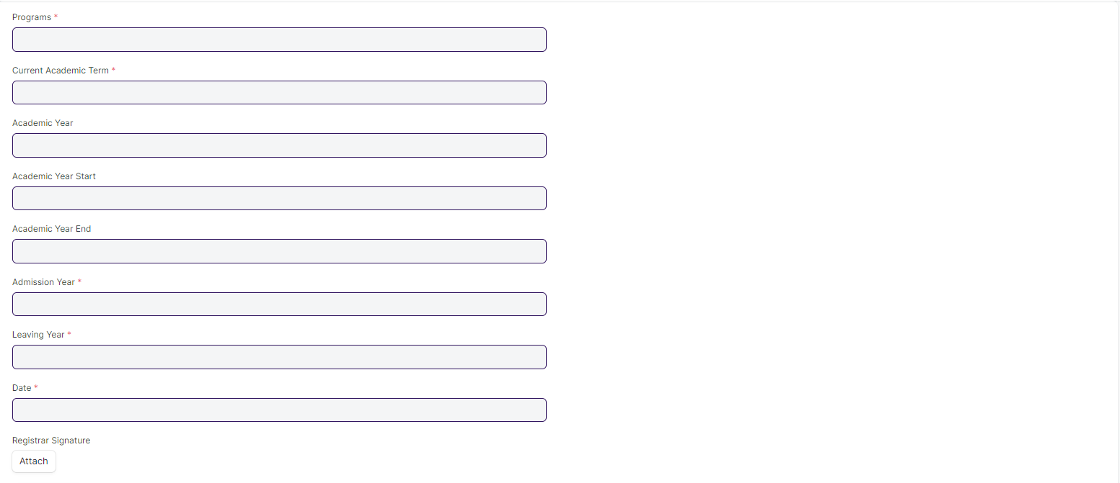

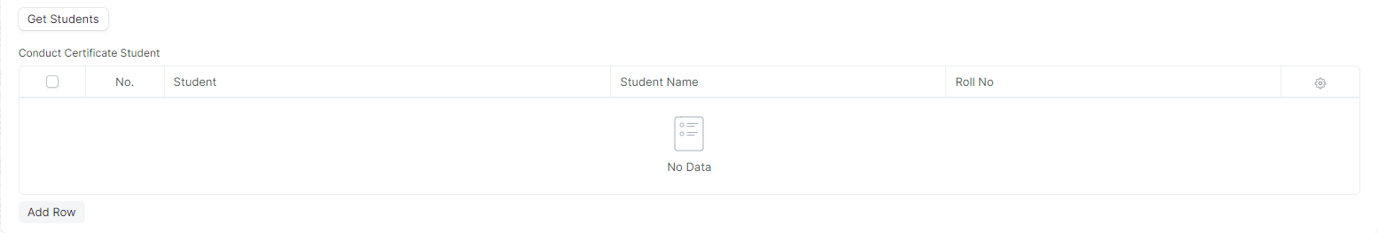

Figure 24 : Conduct Certificate Tool Screen

### Conduct Certificate Tool Field Type :

The “Conduct Certificate Tool” screen shall consist of the following fields:

|  |  |  |  |  |  |
| --- | --- | --- | --- | --- | --- |
| **Field Label** | **Field Type** | **Validation/Action** | **Mandatory** | **Remarks** | **R/N/D** |
| Programs | Link Field | Fetched from Programs master screen | Y |  | (R) Courses |
| Current Academic Term | Link Field | Fetched from Academic Term master screen | Y |  |  |
| Academic Year | Link Field | Fetched from Academic Year master screen |  |  |  |
| Academic Year Start | Date |  |  |  |  |
| Academic Year End | Date |  |  |  |  |
| Admission Year | Data |  | Y |  |  |
| Leaving Year | Data |  | Y |  |  |
| Date | Date |  | Y |  |  |
| Registrar Signature | Attach |  |  |  |  |
| Certificate Creation Status | Dropdown | In Process  Failed  Successful |  |  |  |
| Get Students | Button |  |  |  |  |
| Total Students for Certificate | Int |  |  |  |  |
| Conduct Certificate Student | Table |  |  |  |  |

|  |  |  |  |  |  |
| --- | --- | --- | --- | --- | --- |
| **Conduct Certificate Student** | | | | | |
| **Field Label** | **Field Type** | **Validation/Action** | **Mandatory** | **Remarks** | **R/N/D** |
| Student | Link Field | Fetched from Get Students Button |  |  |  |
| Student Name | Data | Auto fetch based on Student |  |  |  |
| Roll No | Data | Auto fetch based on Student |  |  |  |
| Registration Number | Data | Auto fetch based on Student |  |  |  |

### **User: Roles & Permission**

The following table describes the users and their roles and permissions for the screens :

|  |  |  |  |  |  |  |  |  |
| --- | --- | --- | --- | --- | --- | --- | --- | --- |
| **Role** | **Select** | **Read** | **Write** | **Create** | **Delete** | **Submit** | **Cancel** | **Amend** |
| Admin | Yes | Yes | Yes | Yes | Yes | NA | NA | NA |
| Instructor | No | Yes | No | No | No | NA | NA | NA |
| Student | No | Yes | No | No | No | NA | NA | NA |